✍️ Quick notes

Cohort Call — Week 2 / Module 2 (Claude AI Certification)

Jul 5, 2026

marianna.nechypor@gmail.com sudeunal3334@gmail.com chidioparah@gmail.com Rifat Erdem Sahin

This session reviewed agentic system architectures and token cost management to optimize artificial intelligence professional workflows and outcomes.

Concept of agentic AI systems
- Agentic systems autonomously execute tasks like file operations and web navigation without constant human input.
- Demand for coordinator roles anticipated to rise alongside agentic automation.

AI certification and educational path
- Participants targeting AI certified architect status through courseware.
- Skillshar platform hosts required certification modules.

Token economics and system dependencies
- Token counts serve as primary metric for system usage and electricity costs.
- Token quota exhaustion results in immediate operational suspension.
- Input tokens constitute planning phase and dictate output quality.

Infrastructure and data sovereignty
- Private model deployments prioritized for data sovereignty and security.
- On-premise deployments expected to increase as alternative to cloud-only dependency.

Administrative and operational tasks
- Meeting documentation and project materials management ongoing.

AI Model Comparison and Selection
- Gemini and other AI models demonstrate significant performance variance in image generation and text quality.
- Model selection depends on specific use cases, cost efficiency, and SV benchmarks rather than universal capability.
- Deepseek serves as a low-cost alternative for specialized tasks like code generation despite lacking image capabilities.

Agentic Architecture and Systems Engineering
- Enterprise AI success relies on scalable architectures featuring coordinator and sub-agent hierarchies.
- Sub-agents manage local error recovery and specific tasks, while coordinators handle overarching orchestration.
- Interconnected agent systems automate complex workflows, illustrated by city council PDF parsing operations.

Indexing, Tokenization, and Context Management
- Proper tokenization and indexing optimize cost efficiency and semantic search potential.
- Local indexing via Ollama reduces reliance on cloud resources for large datasets.
- Streaming output delivers data incrementally, offering a distinct approach from standard batch processing.
- Context memory accumulation leads to expanding input token requirements over continuous interactions.

AI Token Management and Cost Efficiency
- AI agents operate as stateless systems requiring improved planning for effective input, output, and cash token management.
- Optimizing token usage remains critical for controlling operational costs and ensuring AI memory performance.
- Target established for developing agentic workflows to reduce manual coding requirements.

System Development and Documentation
- Complex system construction requires orchestrating multiple AI systems alongside precise input token planning.
- Meeting documentation process includes recording sessions for subsequent summary generation via Gemini.

Next steps
- [Rifat Erdem Sahin] Share Whiteboard Link: Share the whiteboard link via WhatsApp for all meeting attendees.
- [The group] Complete Training: Complete the Claude AI certification modules on the Skillshar website by listening to the content and answering the questions.
- [The group] Track Token Usage: Monitor and record daily personal token usage from communications and AI tool interactions to report in the next meeting.
- [The group] Study course materials: Review the uploaded videos and transcripts to improve understanding of artificial intelligence agents and token mechanics.
- [The group] Complete hands-on projects: Implement the 60 animated projects and exam questions provided in the repository to gain practical experience.
- [The group] Execute and modify examples: Run and update the repository examples locally to learn how to manage agentic structures effectively.
- [Rifat Erdem Sahin] Develop Certification Course: Create Gemini AI program.
- [Rifat Erdem Sahin] Translate Visual Content: Perform required language conversions for visuals.
- [Rifat Erdem Sahin] Finalize Content Recordings: Capture necessary video data for the course.
- [Rifat Erdem Sahin] Post Project Materials: Publish finalized media to the designated platform.
- [Rifat Erdem Sahin] Upload Meeting Recording: Save the session file to the shared repository.
- [The group] Analyze Token Usage: Review input, output, and cash structures to understand system efficiency before the next session.

You should review Gemini's notes to make sure they're accurate. Get tips and learn how Gemini takes notes
How is the quality of these specific notes? Take a short survey to let us know your feedback, including how helpful the notes were for your needs.

📝 Full notes
Jul 5, 2026

Cohort Call — Week 2 / Module 2 (Claude AI Certification)
Invited marianna.nechypor@gmail.com sudeunal3334@gmail.com chidioparah@gmail.com Rifat Erdem Sahin
Attachments Cohort Call — Week 2 / Module 2 (Claude AI Certification)
Meeting records Transcript Recording

Summary
This session reviewed agentic system architectures and token cost management to optimize artificial intelligence professional workflows and outcomes.
Defining Agentic System Architectures
The group defined agentic systems as autonomous entities capable of task execution rather than passive prompt following. This shift mandates new roles focused on coordinating artificial intelligence.
Managing Token Costs Efficiently
Participants explored tracking token consumption and selecting specialized models for cost-effective operations. Resilient agent architectures provide superior error recovery compared to naive monolithic systems.
Implementing Automated Agentic Workflows
The team explored building scalable projects by leveraging multiple interconnected artificial intelligence agents. The primary decision was to prioritize comprehensive planning over manual task execution.

Next steps
- [Rifat Erdem Sahin] Share Whiteboard Link: Share the whiteboard link via WhatsApp for all meeting attendees.
- [The group] Complete Training: Complete the Claude AI certification modules on the Skillshar website by listening to the content and answering the questions.
- [The group] Track Token Usage: Monitor and record daily personal token usage from communications and AI tool interactions to report in the next meeting.
- [The group] Study course materials: Review the uploaded videos and transcripts to improve understanding of artificial intelligence agents and token mechanics.
- [The group] Complete hands-on projects: Implement the 60 animated projects and exam questions provided in the repository to gain practical experience.
- [The group] Execute and modify examples: Run and update the repository examples locally to learn how to manage agentic structures effectively.
- [Rifat Erdem Sahin] Develop Certification Course: Create Gemini AI program.
- [Rifat Erdem Sahin] Translate Visual Content: Perform required language conversions for visuals.
- [Rifat Erdem Sahin] Finalize Content Recordings: Capture necessary video data for the course.
- [Rifat Erdem Sahin] Post Project Materials: Publish finalized media to the designated platform.
- [Rifat Erdem Sahin] Upload Meeting Recording: Save the session file to the shared repository.
- [The group] Analyze Token Usage: Review input, output, and cash structures to understand system efficiency before the next session.

Details
Did the screenshots in this section make your notes better or worse?
- Meeting Setup and Technical Check: Rifat Erdem Sahin initiates the meeting and works to resolve audio background noise by utilizing the Crisp platform to ensure clear communication.
- Definition of Agentic Systems: Sudenall reports on their progress studying architecture through GitHub projects, which leads to a discussion comparing prompt-based systems with agentic systems; Rifat Erdem Sahin defines an agent as an entity capable of making decisions and executing tasks autonomously, using an autopilot car analogy to distinguish agentic behavior from simple prompt-following (00:01:29).
- Future of AI Tools and Tasks: Rifat Erdem Sahin and Sudenall discuss the growing integration of AI tools, such as those provided by Google, noting that AI serves as a powerful assistant for tasks like summarizing meetings, though it is not expected to replace all human work (00:04:31).
- Employment and Agent Coordination: Rifat Erdem Sahin suggests that the future of work will involve new roles focused on coordinating AI agents rather than just manual coding; they also discuss how AI and internet connectivity act as democratizing forces for global intelligence, using the SpaceX satellite internet example to illustrate increased access for remote populations (00:06:44).
- Technical Troubleshooting and Meeting Recap: Rifat Erdem Sahin attempts to use AI to blur their background, and Marianna Nechypor joins the call along with Chidi Oparah, prompting Rifat Erdem Sahin to recap the distinction between agentic systems—which can perform actions without constant confirmation—and prompt-based systems (00:08:56).
- Marianna Nechypor’s Project Strategy: Marianna Nechypor shares an update on their business strategies for two companies, Value Link Pro and Expertise Hub, explaining the decision to finalize strategic planning before creating specific tasks to avoid redundant work and resource waste (00:11:55).
- Hierarchy of AI Interface Costs: Rifat Erdem Sahin categorizes AI interfaces by their cost and efficiency, identifying Chat as the most affordable, Co-work as the most expensive due to human-machine collaboration, and Code as the most agentic and fastest method for production (00:14:38).
- AI Architect Certification and Industry Context: Rifat Erdem Sahin details the goal of becoming AI-certified architects using Anthropic's Claude, providing an overview of the financial scale of leading AI companies and comparing their revenue to the GDP of countries like Turkey to emphasize the economic importance of the industry (00:16:56).
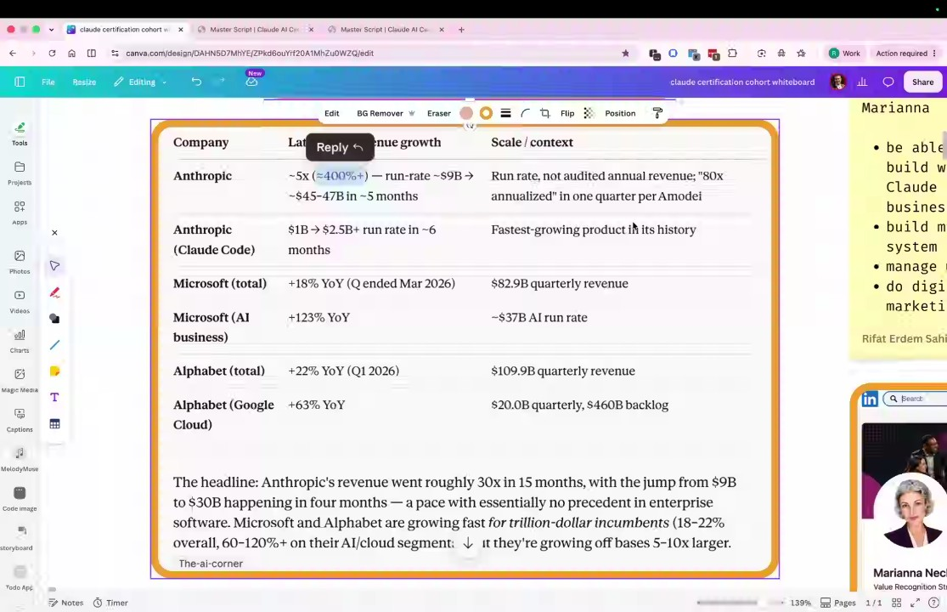
- Training and Accountability: Participants confirm their registration and progress on the Skilljar training website, with Rifat Erdem Sahin stressing the importance of completing the certification modules to build professional credibility (00:19:07).
- Paperclip AI Company Concept: Rifat Erdem Sahin introduces the "Paperclip AI company" concept, describing a shift toward a future where individuals with limited technical backgrounds can build complex businesses by leveraging multi-skilled AI agents (00:20:54).
- Tokenization and Usage Tracking: Rifat Erdem Sahin explains the concept of tokenization—the units of words/data AI processes—and tasks the group with tracking their personal token consumption in the coming week to understand the cost of their AI dependency (00:22:56).
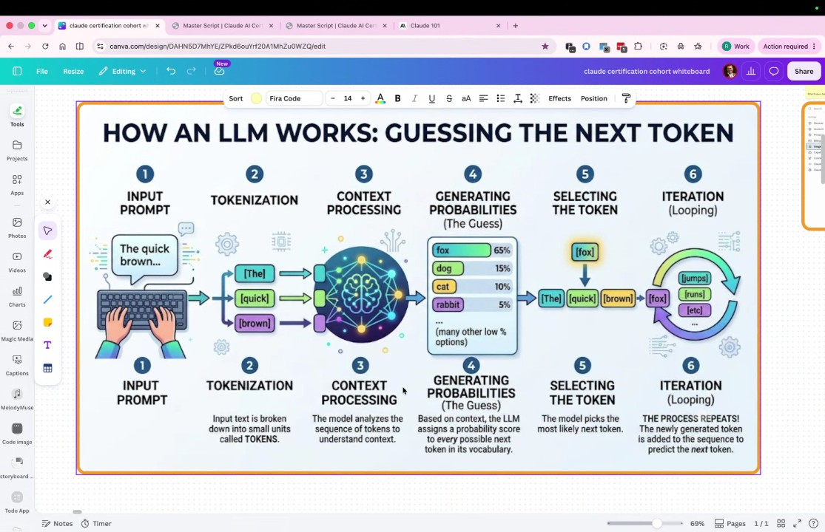
- Personal Token Usage and Subscription Limits: Rifat Erdem Sahin shares their own usage statistics, revealing that their £16 monthly subscription was fully exhausted after consuming 120 million tokens in 30 days, serving as a case study for the group on resource limits (00:26:06).
- AI Dependency and Strategic Superiority: The group discusses the strategic necessity of AI, drawing an analogy to the Ukraine-Russia conflict where technological superiority is a decisive factor; Rifat Erdem Sahin reports using approximately 370 million tokens in a single day across four different AI models (00:27:56).
- Overview of AI Models: Rifat Erdem Sahin outlines their daily toolset, including Gemini for images, Claude for coding, ZAI for job applications, and DeepSeek for cost-effective tasks, reiterating the importance of knowing these limits (00:30:02).
- Service Limits and Cloud Migration Parallels: Rifat Erdem Sahin demonstrates what happens when usage quotas are exceeded, warning that reliance on AI tools carries the risk of service interruptions, much like historical cloud migration challenges (00:31:54).
- Alternative Cost of Development: Rifat Erdem Sahin emphasizes that while AI use incurs costs, the alternative cost—such as hiring expensive developers—is significantly higher, making AI integration economically logical for small businesses (00:34:06).
- Live Tokenization Demonstration: Rifat Erdem Sahin conducts a live demo showing that even a simple "hello" command generates significant token context (15,000 tokens) because the system must account for environment variables, cached data, and session context, despite the output being only nine tokens (00:36:21).
- Semantics and Computational Cost: Rifat Erdem Sahin explains that AI models require significant electricity and computational power to "guess" tokens accurately, highlighting that the "intelligence" provided by AI is tied to these energy-intensive operations (00:39:48).
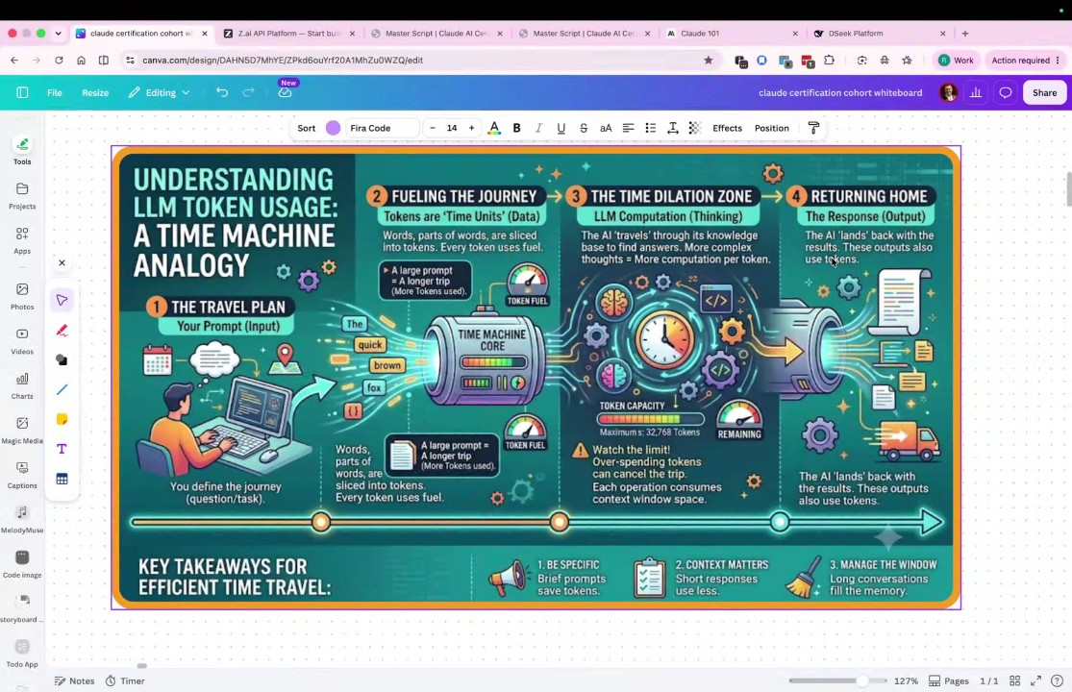
- Diverse AI Models and Specialized Tasks: Rifat Erdem Sahin points to Hugging Face as a repository for various AI models, noting that different models are specialized for distinct tasks like video, audio, or infographic generation rather than being monolithic entities (00:42:06).
- Public versus Private Models: Rifat Erdem Sahin explains that while models like Claude and ChatGPT are public, many organizations maintain private models to protect proprietary data and maintain sovereign control over their information, particularly in sensitive industries (00:44:20).
- Architecture and Data Sovereignty: The group discusses AI architecture, including "Mixture of Experts" models, and Rifat Erdem Sahin warns about data residency risks, noting that while local tools offer more control, cloud-based tools often route data through the United States, which may conflict with local regulations or privacy needs in other countries (00:46:20).
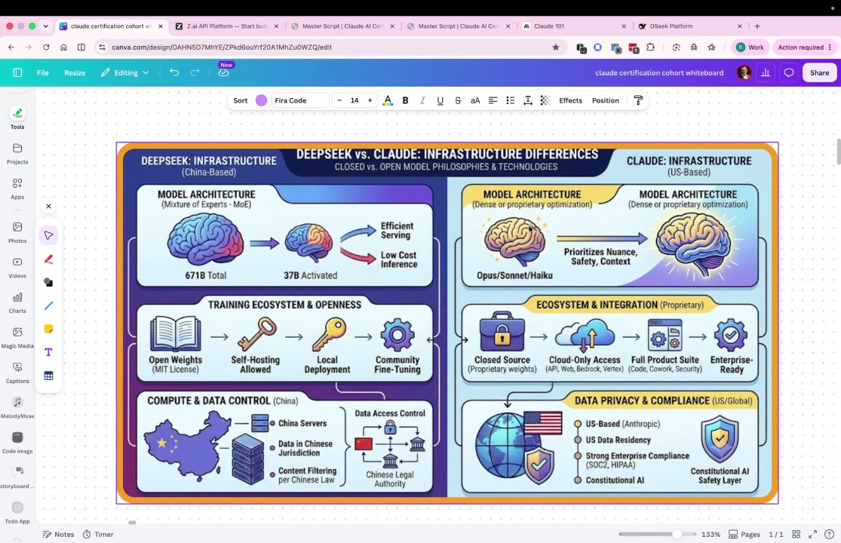
- Automation and Agency: Marianna Nechypor describes using AI to automate job application analysis, prompting Rifat Erdem Sahin to reinforce that the level of agency increases as one moves from Chat to Co-work to Code (00:48:28).
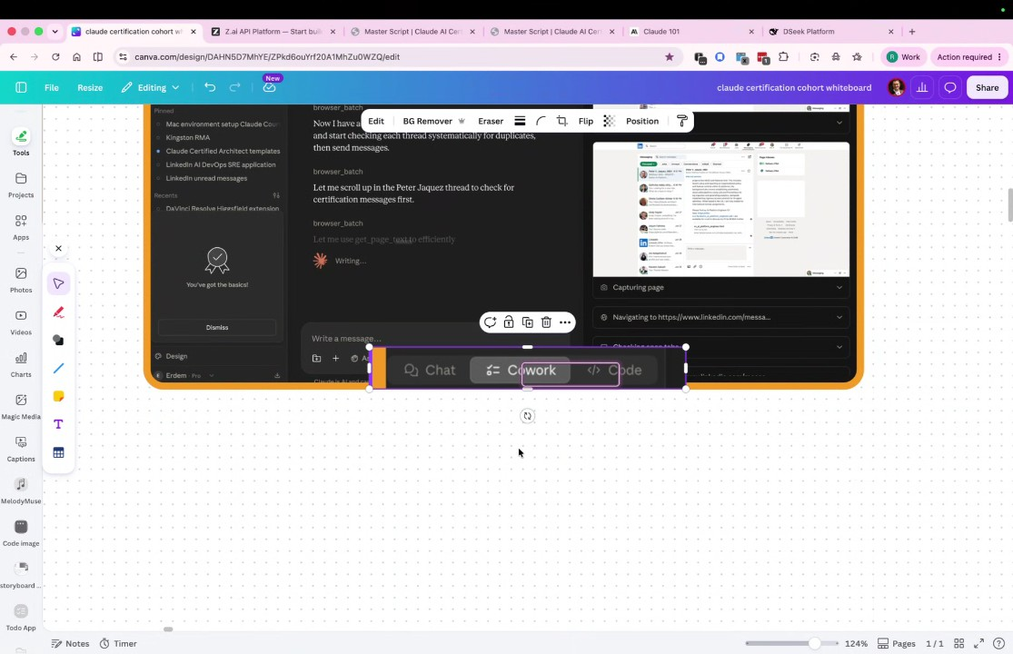
- Review of Resources and Automation: Rifat Erdem Sahin confirms that meeting reporting and transcription are handled by automated AI agents like Gemini, encouraging participants to recognize the multiple hidden AI processes active in their workflows (00:50:51).
- The Human Role as AI Architect: Rifat Erdem Sahin asserts that the future role of humans will shift toward asking increasingly complex and high-quality questions to AI; Marianna Nechypor notes that they are refining their input strategy to optimize results and minimize unnecessary token expenditure (00:53:52).
- Impact of Planning on Output: Rifat Erdem Sahin concludes with an image generation demo showing that identical prompts can yield vastly different qualities—one poor and one polished—depending on the depth of the initial input tokens and planning provided to the model (00:57:03).
- AI Model Selection and Image Quality: Rifat Erdem Sahin discusses why different AI models produce varying results, noting that Gemini generates high-quality images while other tools like Combas AI often produce "gibberish" or low-quality output (00:58:12). The consensus is that users must evaluate and select specific models for different tasks, as not all AI tools possess the same capabilities for text and image generation (01:00:41).
- Understanding SB Scores: Rifat Erdem Sahin introduces Software Benchmark (SB) scores as a method to evaluate AI performance across various tests, including math, imagery, and video questions (01:01:39). The group agrees that higher SB scores correlate with better performance, and participants should use these scores to make informed decisions when choosing AI tools for specific projects (01:03:11).
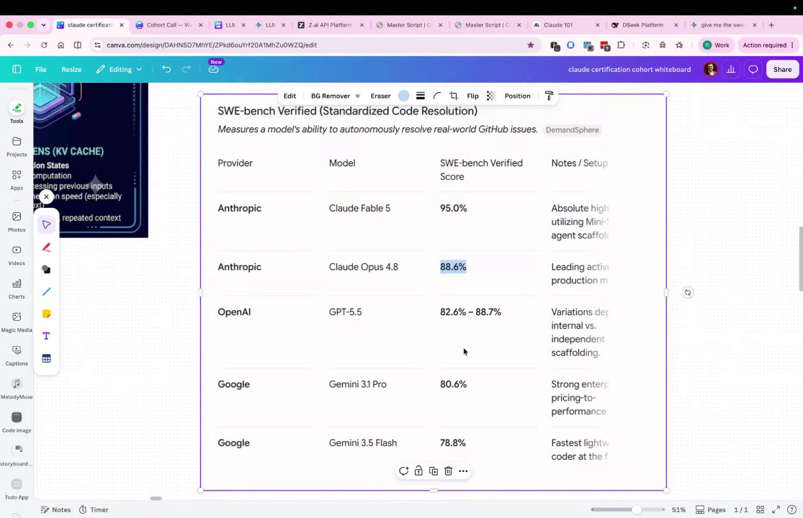
- Use-Case Specific AI Selection: Rifat Erdem Sahin explains that the choice of AI depends on the specific job, with DeepSeek preferred for coding to save money and Gemini favored for image generation (01:05:14). The participants agree that efficient use of AI requires identifying which tool offers the best value and performance for the specific task at hand, rather than relying on a single AI for all requirements (01:04:12).
- AI Strategy and Competition: Rifat Erdem Sahin compares the competitive strategies of large entities like Google versus smaller organizations like DeepSeek. The discussion highlights that DeepSeek competes by focusing on a specific niche—code writing—and offering a significantly more affordable, iterative service that allows users to change requirements frequently without high costs (01:06:26).
- Financial Models for AI: Rifat Erdem Sahin differentiates between subscription-based AI services, which charge regular fees, and API-based models, which function on a pay-per-use basis. The consensus is that users must understand these distinct financial models to effectively manage costs, choosing between subscriptions for consistent needs or API access for flexible, task-specific use (01:07:36).
- Project Implementation and Repository Management: Sudenall shares their experience with Rifat Erdem Sahin's repository, which contains over 60 exam-based projects (01:09:42). Rifat Erdem Sahin encourages participants to fork projects and build their own repositories to gain hands-on experience, noting that Sudenall has successfully begun managing their own project branches (01:10:59).
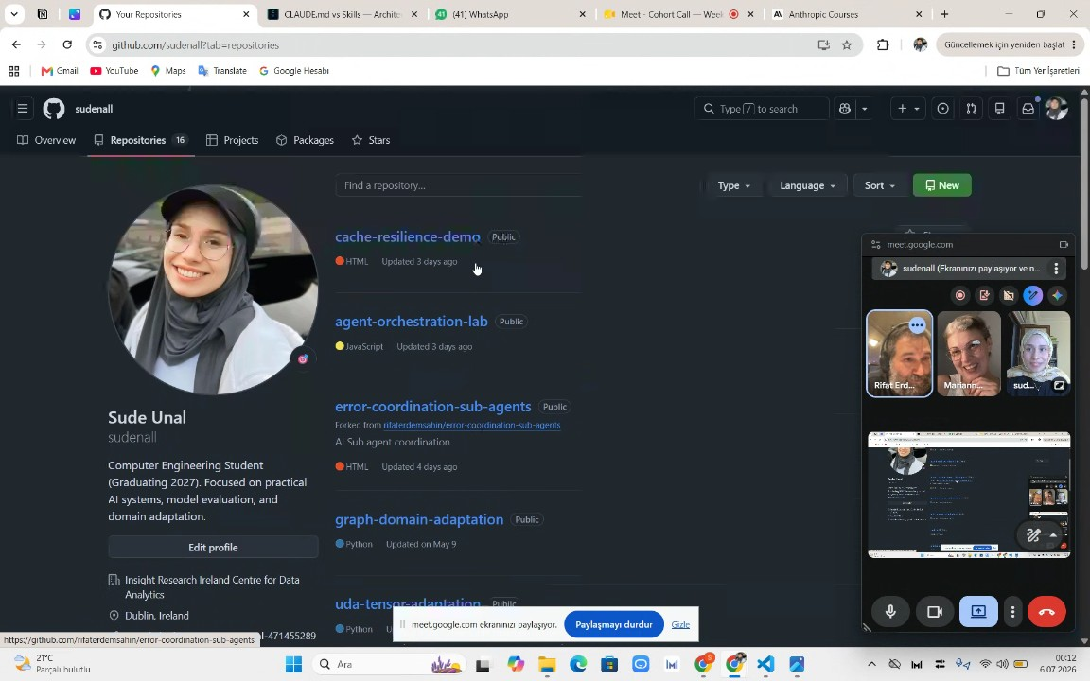
- Agent Architectures and Sub-agents: Rifat Erdem Sahin defines the roles of sub-agents and coordinators in AI system architecture (01:13:02). The discussion addresses the problem of system termination due to parsing errors in PDF files, with the group concluding that sub-agents should handle localized error recovery while the coordinator manages the overall system flow (01:14:08).
- Automated Error Management in Administrative Tasks: The group explores applying agentic solutions to administrative tasks, such as processing city council PDF files (01:16:41). Rifat Erdem Sahin argues that implementing error management at the sub-agent level is more token-efficient than managing errors at the coordinator level, noting that AI agents are increasingly poised to replace manual processes in these sectors (01:17:37).
- Naive Versus Resilient Agent Terminals: Rifat Erdem Sahin compares naive agent terminals, which attempt all tasks independently, against resilient agent terminals that delegate tasks to specialized sub-agents (01:20:36). The analysis demonstrates that resilient architectures are more efficient and less prone to errors, making them the preferred approach for professional AI applications (01:21:44).
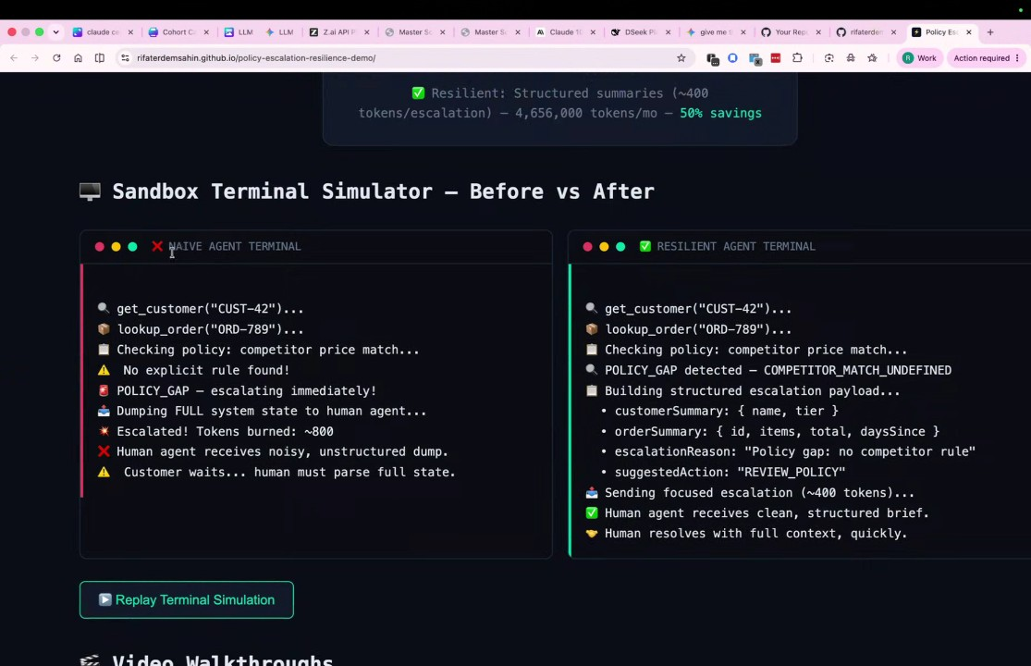
- Strategy for Course Construction: Rifat Erdem Sahin details their method for building a certification course, which involves using AI to automate the creation of scripts, outlines, and database management for over 200 pages of content (01:24:15). This automated approach allows for business scalability and reduces the labor-intensive requirements traditionally associated with course development (01:25:33).
- Systems Architecture in Enterprise AI: Rifat Erdem Sahin illustrates the shift from simple prompt-based AI interaction to complex, interconnected enterprise systems (01:31:15). The group agrees that enterprise AI is defined by the orchestration of various agents, such as accounting, payroll, and marketing, that communicate with each other rather than functioning as isolated tools (01:32:30).
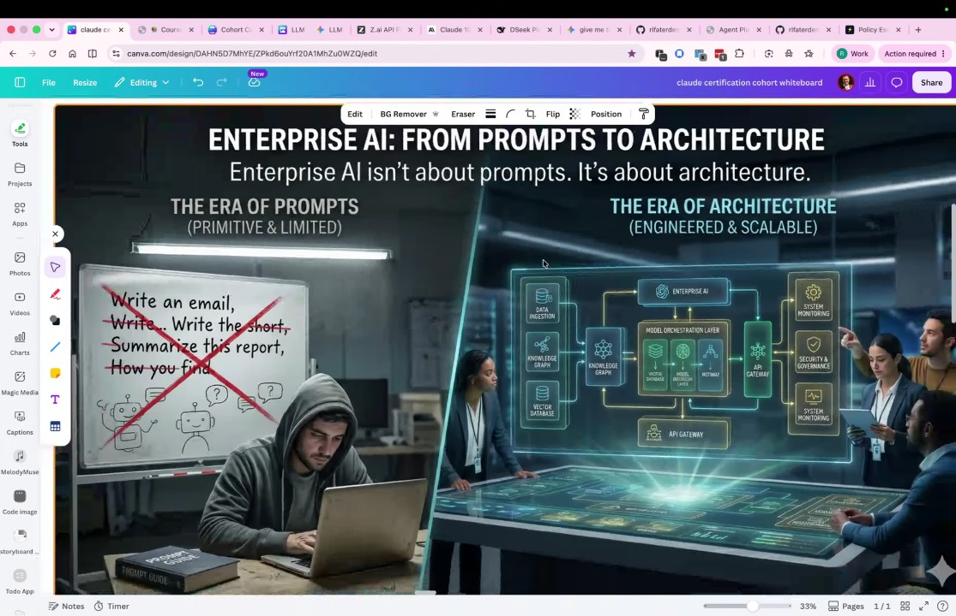
- Local Indexing and Tool Utility: Rifat Erdem Sahin demonstrates the importance of code indexing and utilizing tools like Ollama for local document management (01:37:25) (01:40:42). The group observes that while some AI operations require cloud access, specific tasks like indexing are better handled locally on a user's machine to optimize token usage and system performance (01:38:35) (01:40:42).
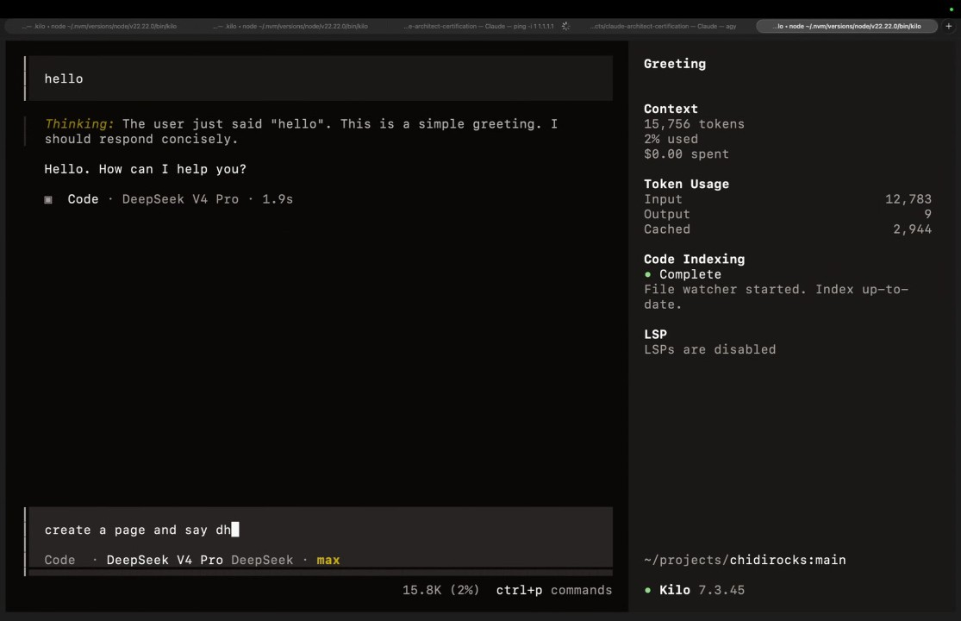
- Local AI Execution and Data Privacy: Rifat Erdem Sahin explains that local AI models, such as those owned by Meta, utilize user data for training (01:42:12) (01:45:24). The discussion clarifies that free services often extract value by training models on user input, and participants recognize the trade-off between using these services and the potential for data extraction (01:44:20).
- Competitive Advantage Through Data: Rifat Erdem Sahin highlights that companies with access to larger datasets hold a significant advantage in training their AI models (01:51:13). This access to user-generated content allows these organizations to produce more effective agents and stay ahead in the competitive AI landscape (01:49:59).
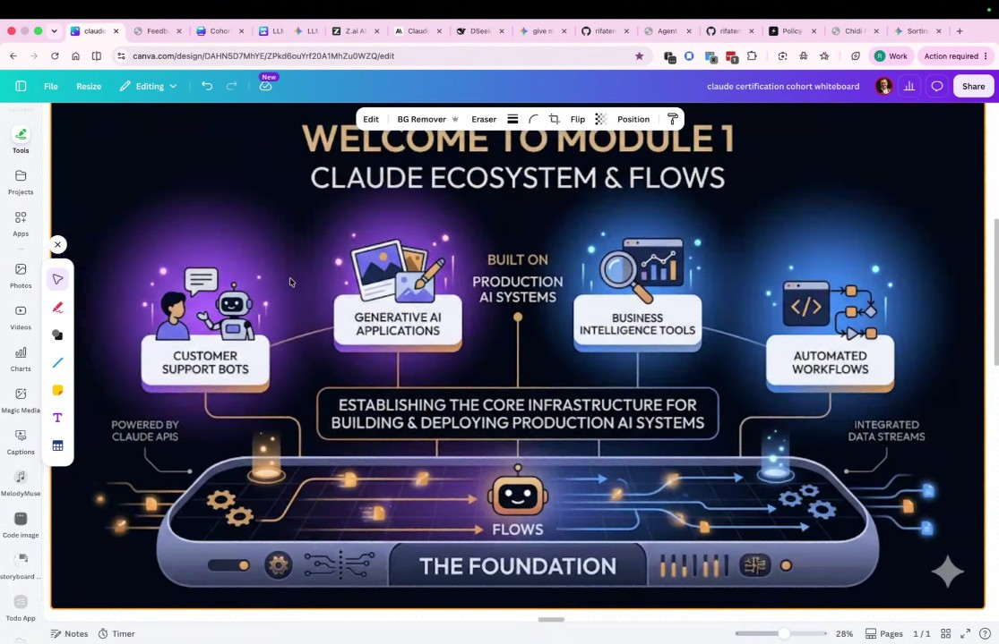
- Streaming Versus Batch Processing: Rifat Erdem Sahin defines streaming as the method where AI generates output piece-by-piece, compared to batch processing (01:52:15). The participants note that streaming is essential when the processing cost for the AI to predict subsequent words is high, necessitating delivery in smaller, manageable segments (01:53:29).
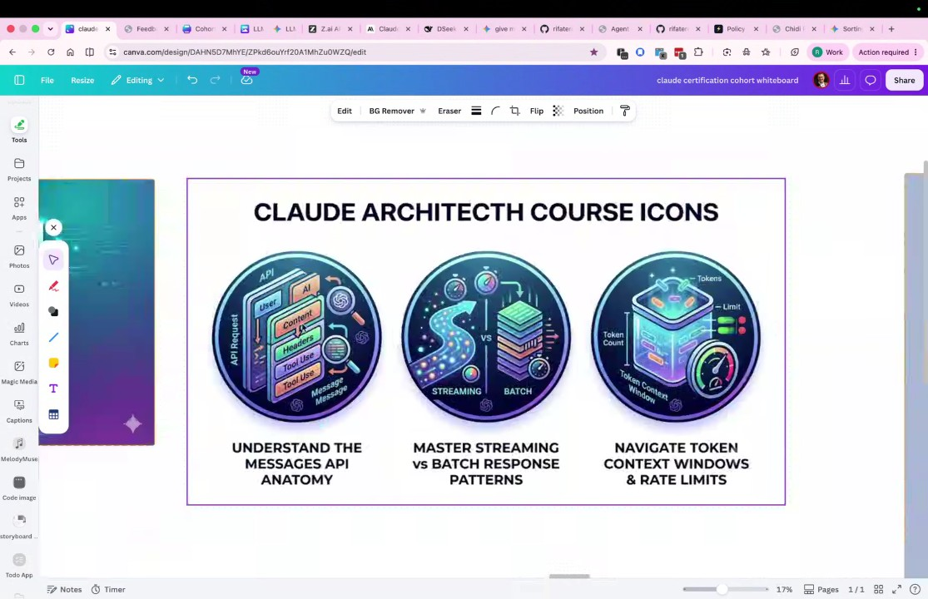
- Stateless Systems and Context Management: Rifat Erdem Sahin explains that models like Claude operate as stateless systems, meaning they lack inherent memory and require previous context to be re-loaded with each new request (01:54:44). The group concludes that users must be mindful of how increasing input tokens across consecutive interactions impacts system performance and costs (01:55:41).
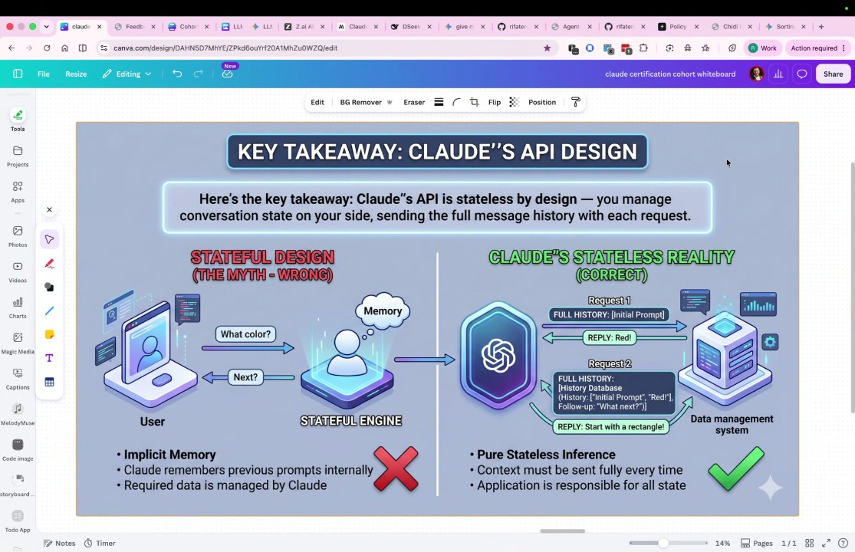
- Importance of Token Management and Cost Efficiency: Rifat Erdem Sahin emphasizes that because AI agents operate as stateless systems, the team must improve their planning to manage input, output, and cash tokens effectively. Rifat Erdem Sahin explains that these token types dictate the overall costs of the system and influence the selection of the large language model required for complex business operations. To optimize, Rifat Erdem Sahin encourages the team to understand their specific token usage and learn to operate in an agentic manner without manual coding (01:56:49).
- AI Agentic Workflow Implementation: Rifat Erdem Sahin clarifies that users should not perform tasks manually, but should instead explain their requirements so the AI agent can take over the execution. To illustrate this, Rifat Erdem Sahin shares that they are currently building a 200-page website over a four-week period by leveraging multiple AI systems to handle various components of the project. Rifat Erdem Sahin notes that they recognized the need to use a combination of AI systems and clear planning to ensure both the human and the computer can understand the objective (01:58:12).
- Meeting Documentation and Conclusion: Rifat Erdem Sahin informs the team that they will record the call and use Gemini to generate a Word document for reference. Rifat Erdem Sahin invites the team to review the document and confirms that the recording and transcription will stop following the conclusion of the session. Rifat Erdem Sahin then concludes the presentation portion of the call by asking if there are any questions from the team (01:58:12).

You should review Gemini's notes to make sure they're accurate. Get tips and learn how Gemini takes notes
How is the quality of these specific notes? Take a short survey to let us know your feedback, including how helpful the notes were for your needs.

📖 Transcript
Jul 5, 2026

Cohort Call — Week 2 / Module 2 (Claude AI Certification) - Transcript

00:00:25

Rifat Erdem Sahin: Hello Sud, how are you? Are you speaking? Yes. All right.
sudenall: Yeah,
Rifat Erdem Sahin: Okay. I will adjust my audio. Can you hear my background noise?
sudenall: a little
Rifat Erdem Sahin: a little bit.
sudenall: bit.
Rifat Erdem Sahin: Let me try to figure this out this time.
sudenall: Okay.
Rifat Erdem Sahin: I don't have get the chance to use the first that much. Um hopefully it will work this time.
sudenall: Sometimes it's
Rifat Erdem Sahin: Sometimes it's cutting.
sudenall: cutting.
Rifat Erdem Sahin: All right. Uh the microphone is hear me now on crisp. Can you hear me?
sudenall: Yeah.
Rifat Erdem Sahin: Yes. So this is now on crisp. So the crisp has a virtual speaker and the virtual microphone. The background noise should be deleted. I guess there is a football game today.
sudenall: Yeah.
Rifat Erdem Sahin: How was your week? Uh Sud, I started the recording.

00:01:29

sudenall: Yeah.
Rifat Erdem Sahin: GD mic join and GD mic join and um um yes Start.
sudenall: Yeah. I started uh for some practice for the um understanding the
Rifat Erdem Sahin: Yeah.
sudenall: architecture better from your um GitHub codes. Well, I did some projects about it and uh everything more clear now.
Rifat Erdem Sahin: What did you do uh by looking into those projects?
sudenall: um sub agent error coordination project I've I've been looked and
Rifat Erdem Sahin: There's all
sudenall: some I un understood some architecture like if error
Rifat Erdem Sahin: finished.
sudenall: becomes or um it should be resolved by the sub agents and or the coordinator should do some things like task allocation but never did do some task like this or um after coordin ator takes results from different sub agents. It passes them to another agents for merging processes. I
Rifat Erdem Sahin: All right. What we understand from these
sudenall: Yeah.
Rifat Erdem Sahin: agents?
sudenall: Um first what which extents
Rifat Erdem Sahin: So in the past we were not using agents. Now the agents become the important keyword in our conversation.

00:03:04

sudenall: agents
Rifat Erdem Sahin: What's your understanding of an agent
sudenall: do some tasks um instead of the coordinator. All of the task is running uh by the
Rifat Erdem Sahin: instead of by the agents?
sudenall: agents.
Rifat Erdem Sahin: What is the difference between running as a prompt versus running as an agent?
sudenall: Uh, running is a prompt is running all of the tasks. Um, yeah, I I need to think about
Rifat Erdem Sahin: Such is once you are driving a car,
sudenall: it.
Rifat Erdem Sahin: you are giving all the prompts to the car. But once the car is in autopilot, when the car is driving, you are behind the wheel. It is agentic. The car takes over, turns right, and if it makes decisions, it is agentic. Agent comes from agency meaning it is able to make the decisions without asking you write the files go to the website make a summary do everything on an agentic manner in our call right now on the left hand side there is something called summarize this discussion did you see that there is the AI on our screen on the left hand side I can say what are they talking about agents What are they uh

00:04:31

sudenall: Oh Yeah.
Rifat Erdem Sahin: talking about agents? Do you see that uh on the left hand side on here?
sudenall: Yeah. Mhm.
Rifat Erdem Sahin: here. So there's an agent in the background that made the decision to listen to our call to
sudenall: Yes.
Rifat Erdem Sahin: transcribe it and be able to answer it. Do you see it says sub agent error coordination agent conceptual definition and analogy and the task management? So it is giving us the issues in the background. Why do you think the Google is putting all of these tools into its tool set?
sudenall: uh for running the tasks with the different um manners.
Rifat Erdem Sahin: different manners, different use cases such as Marianna didn't join the meeting right now.
sudenall: Mhm.
Rifat Erdem Sahin: She can join the call, write to the agent what did they talk so far. Summarize it will be able to summarize our 10 minutes of a talk in three four sentences so she can catch up easier. So the AI gives us new use cases in the world that was not

00:05:30

sudenall: Mhm.
Rifat Erdem Sahin: possible in the past. Five years ago the teams was something that is new that was interesting.
sudenall: Yeah.
Rifat Erdem Sahin: People go to the teams. Now the teams is listening and doing the actions in the background. What is the future of agents in your mind?
sudenall: They will they will run all of our task in the future. Our personal
Rifat Erdem Sahin: Does calculator run all all your banking in the right
sudenall: task.
Rifat Erdem Sahin: now?
sudenall: What?
Rifat Erdem Sahin: Does your calculator app run all of your banking or budgeting?
sudenall: No.
Rifat Erdem Sahin: No. So the AI is probably not going to run everything. If it is a tool, it will not run everything. But if it can make the decisions with itself then it might be able to run more than you think but not as much as you think. Most of the time once there's a new technology everybody gets very excited. It doesn't do the all the dreams but it also doesn't do the minimum.

00:06:44

Rifat Erdem Sahin: So it always lands in the middle. So my expectation is these agents uh because the people are afraid. At my job, people don't want to use agents because they think they are going to lose their jobs. What do you think about them? Do you think people lose their jobs because they are agents?
sudenall: No, actually because uh actually I think that more jobs will become occur for the coordinating the agents.
Rifat Erdem Sahin: Coordinating the agents will become a job and there will be more coordinators in the future
sudenall: Mhm.
Rifat Erdem Sahin: such as your my audience is you guys software developers not software
sudenall: Yeah.
Rifat Erdem Sahin: architects, devops or the sur people but you uh Marianna Nechypor people not hardcore writing the code every day but they try to use the AI to do their job. So there's going to be a new community coming in.
sudenall: Yeah.
Rifat Erdem Sahin: Think about people all over the globe. The world is changing right now. Such as you see these SpaceX a billion dollar company.

00:07:50

sudenall: Mhm.
Rifat Erdem Sahin: What what do they do? Do you know what they do?
sudenall: No, actually
Rifat Erdem Sahin: What they do it is they send satellites for internet.
sudenall: Mhm.
Rifat Erdem Sahin: Right now you are living in a big city, right?
sudenall: Yeah.
Rifat Erdem Sahin: But most of the world is not living in a big city. What SpaceX does is what AI does is uh it enables 80% of the remaining world. It is not living in the cities to be as smart as the city
sudenall: Oh
Rifat Erdem Sahin: people with AI and with internet because
sudenall: yeah.
Rifat Erdem Sahin: if you have internet you can reach the AI. If you have the AI you have the intelligence.
sudenall: Mhm.
Rifat Erdem Sahin: So the idea of the people in the villages are not smart is not going to be valid anymore because the intelligence
sudenall: Yeah.
Rifat Erdem Sahin: was always collected in the big cities but that is not going to be the case.
sudenall: Yeah.
Rifat Erdem Sahin: The people in my background can be seen.

00:08:56

Rifat Erdem Sahin: I need to blur that somehow one way or the point. I could not find how to blur the option. There's a blur link, but I don't know how to trigger that blur option.
sudenall: f***.
Rifat Erdem Sahin: Sound effects, the cameras, video, audio, desktop notifications. I don't know how to blur this. Uh, if I ask AI,
sudenall: I'm trying to find
Rifat Erdem Sahin: do you think let's ask the AI, can you blur my screen? If this is an agent,
sudenall: Okay.
Rifat Erdem Sahin: can you blur my background? Do you see what I'm writing on the left?
sudenall: Yes.
Rifat Erdem Sahin: So once I write this, if if it is aentic, it should be able to blur my background in here. If it is agentic, I will put this onto our uh diagram on here. I will not start. I will wait for Marianna. But at least put the items over there.
sudenall: Okay.
Rifat Erdem Sahin: Let me select this one.

00:09:57

Rifat Erdem Sahin: And I will uh do a catch up of last week what we have gone through but we are here.
sudenall: Mhm.
Rifat Erdem Sahin: So can you blur my background when I asked that and if it is able to do that this means this is agentic. It can take the actions go and click the button and blur my background in the back. But probably it is not that agentic and it is unable to make that decisions. Before joining it says go to Google meet blur during the meeting at the bottom microphone video settings. Microphone video settings. Yes. So what do I do? Video settings. Click blur background. I don't see blur background here though.
Marianna Nechypor: Guys,
Rifat Erdem Sahin: But that's all right. Marianna is here.
Marianna Nechypor: sorry. Sorry for being late.
Rifat Erdem Sahin: Hello
Marianna Nechypor: Probably Adam,
Rifat Erdem Sahin: Mariana.
Marianna Nechypor: you told you told you told Sud that I was on my

00:10:54

Rifat Erdem Sahin: Yes,
Marianna Nechypor: way.
Rifat Erdem Sahin: I saw Mariana while I'm coming. Cambridge is a very small city. So we see each other. I'm coming to Vegas. Uh she is going home. I told her to come and join here because there is so much noise. There's English game in the background. Mariana wants to go to her home and join from home. I think it is better for her. I also mentioned it to Chidi um my uh we work together with Chidi in uh Oman in Goldman Sachs. He was going to join but something came up probably he's not joining.
Marianna Nechypor: Huh? Uh-huh.
Rifat Erdem Sahin: So what did we talk about before you arrived here? Um the difference between agentic systems and the non-agentic systems. Agentic systems able to make the decisions and uh do the actions without asking
Marianna Nechypor: Yeah.
Rifat Erdem Sahin: us lots of confirmations. Prompt based systems are the systems that give us the intelligence but let's makes us do the actions.

00:11:55

Rifat Erdem Sahin: What did you do in terms of AI Mariana this week?
Marianna Nechypor: uh this week I was publishing my strategy of my two two companies because there's one one value link pro it's about me and what I'm providing and uh another one the expertise hub and uh what I did I wanted to create uh I've created the product for developing the website uh for for developing tasks what I I've
Rifat Erdem Sahin: All
Marianna Nechypor: started but then I stopped because I decided that I have to
Rifat Erdem Sahin: right.
Marianna Nechypor: finalize my strategy to be clear with two with these two uh products and After that I will create task that I'm trying to polish and to update website and I want to I want we started to create the expertise hub website. How noisy from
Rifat Erdem Sahin: All right. In terms of AI,
Marianna Nechypor: our
Rifat Erdem Sahin: what did you do? You worked on this such as um uh such as Sud said she worked on she looked at the agentic things. Did you work with AI to decide on how you are going to make the decision?

00:13:25

Marianna Nechypor: Um look I can show you
Rifat Erdem Sahin: Share your screen so that we can
sudenall: Action.
Marianna Nechypor: here just to share you and to show you.
Rifat Erdem Sahin: see.
Marianna Nechypor: Um, look, I I started to create I want to update and to make value link pro website more functional and I started
Rifat Erdem Sahin: All right.
Marianna Nechypor: that but uh but my second project but then and I wanted to I want to co-work Yeah.
Rifat Erdem Sahin: Yes, we are
Marianna Nechypor: And I wanted Yeah.
Rifat Erdem Sahin: listening.
Marianna Nechypor: I wanted to create value in pro methodology but then
Rifat Erdem Sahin: Yes.
Marianna Nechypor: then I stopped because I before I create tasks I want to be clear what steps I want to do. The system suggested five or few steps but I want to go deeper. Then I came back to the beginning and started to polish my strategy because I don't want to waste time to creating tasks, you know, and then to repeat them again and
Rifat Erdem Sahin: Yeah, this is what Sud mentioned about the agents.

00:14:38

Marianna Nechypor: again.
Rifat Erdem Sahin: On the left hand side there is chat in the middle there is cover and on the right hand side
sudenall: Nothing.
Rifat Erdem Sahin: there is um there is code. So the code section is the most agentic section because it is going to make the decisions to build your website.
Marianna Nechypor: Mhm.
Rifat Erdem Sahin: The co-work section you guys are working together side by side.
sudenall: What?
Rifat Erdem Sahin: The chat section is it is giving you the intelligence but you have to execute on the intelligence. So which part is more expensive?
Marianna Nechypor: I think that chat chatting is more expensive.
Rifat Erdem Sahin: No chatting is the cheapest.
Marianna Nechypor: Really? Coding
Rifat Erdem Sahin: Yes. What do you
Marianna Nechypor: coding.
Rifat Erdem Sahin: think?
sudenall: I think coding. No, no, not coding. processing some files. Maybe
Rifat Erdem Sahin: Uh my question is is covert more expensive chat is more expensive or code is more expensive.
sudenall: I
Rifat Erdem Sahin: Yes, coork is more expensive. Two times more expensive than the code and it is going to take more.

00:15:52

sudenall: think
Rifat Erdem Sahin: Think about this like having two engines a human engine and the normal engine working at the same time. code is like an electric motor that runs automatically. The chat is the simplest way that you are going to do most of the action. So the chat is the cheapest. Cohort is the most expensive. The agentic part is the fastest. The code part is the fastest. If you are going to build a website Marianna, it is better for you to use the code parted code deploy for yourself in an agentic manner. So you deal with the output as well. I will share the screen and we will in a very fast manner uh go over what we did last week and I will take you guys through this week. I did put all the slides on here but I will take you guys to here what we are doing. We are going through the Claude. Uh this is the chat interface.

00:16:56

Rifat Erdem Sahin: I'm repeating this is the chat interface. They put at the bottom all these uh related uh connectors at the bottom. So these are called the connectors. I will put them on here. Most of time people get confused. They the bottom is all the connectors. Connectors. Uh so you see the Google drive connector, you see the Gmail connector. It is able to connect the data can be taken from different sources. What did we talk about the Claude? Claude is a very fast growing company with $50 billion in revenue but similar valuation to Walmart like a trillion dollar company. What we are going to do it is we are going to become a AI certified architect. At the end of this you go everybody will get including myself will get the certification. That is our goal to pass one exam. you guys can get customers or you guys can get employed around this.

00:17:57

Rifat Erdem Sahin: We talked about this Entropic is the fastest growing company right now in the world in terms of coding uh in terms of the AI models. This is the run rate for uh for open AI alphabet and the code all related one by one to each other. Do you guys understand these values on here? Billion dollars. These are billion dollars, $200 billion, $460 billion. If you guys want to understand, Turkeykey's GDP is $1 trillion. Claude only one company is $1 trillion. Does it make sense with you guys? It is making as much money as one country, Turkey. Turkey is not a small country. So, it it is making lots of money uh in its turn. We did go over, we will do Mariana's business. We will do a deep dive into this and Sud wants to be able to use the Claude to be able to demonstrate her expertise. We want to make sure that we should be able to add all of that to the websites that the Marianna has.

00:19:07

Rifat Erdem Sahin: And this is the output that we all want to be able to get. Cloertified architect. Did everybody go to the skillshar website? Did you guys all go to the skills jar website?
Marianna Nechypor: Yeah, we did. Hey
Rifat Erdem Sahin: Yes. Is it clear the skill jar website and there is uh multiple videos in each se
sudenall: there.
Marianna Nechypor: there.
Rifat Erdem Sahin: section. Uh were you guys able to go to the skills jar website register there and
sudenall: Okay.
Rifat Erdem Sahin: be able to see them? Uh so did you do that? Did you go to the skillshar website from what
Marianna Nechypor: Yes. Yes. Yes. Yes.
sudenall: Thank
Rifat Erdem Sahin: did you guys see in the skillshar website? What is the difference on what we are doing versus what skills
Marianna Nechypor: They have different things.
Rifat Erdem Sahin: share
Marianna Nechypor: We should start from cloud 101.
sudenall: you.
Marianna Nechypor: I started already. I'm in the beginning like

00:20:02

Rifat Erdem Sahin: in the beginning uh this one there is more accountability you guys join at 9:00
Marianna Nechypor: Yeah.
Rifat Erdem Sahin: p.m. people come in. I try to invite more people in the other one. You guys are responsible to complete it. Please complete it. The content is good. Listen to it. Answer the questions. Try to do it as much as you guys can. So don't only rely on this training. Uh that is the Claude certified training and try to get this training. This training it gives you a basic uh certificates at the end. You guys should be able to add and demonstrate.
Marianna Nechypor: I don't see a screen.
Rifat Erdem Sahin: But the one that you guys can't see my screen.
Marianna Nechypor: Are you
Rifat Erdem Sahin: I will share. No, I'm sharing.
Marianna Nechypor: sharing
Rifat Erdem Sahin: I will share it one more time. Can you guys see the screen now?

00:20:54

Rifat Erdem Sahin: Can you guys see the screen?
Marianna Nechypor: I I don't see I see that there is a screen but I don't see the content. I don't see the
sudenall: Yeah, me too.
Rifat Erdem Sahin: All right. It is loading right now. Yes,
sudenall: That's green screen.
Marianna Nechypor: picture.
Rifat Erdem Sahin: I will switch to my phone if the internet is a problem. Let me check. The internet connection is red. I can see the connection is red. Let me go back to my mobile phone. Maybe it will fix it.
sudenall: Okay.
Rifat Erdem Sahin: Yeah, my mobile phone is the backup. Sometimes it is better than the uh internet connection here. I might for a second. I'm getting the internet either from the picture house or from
sudenall: So there is a different certificate from this.
Rifat Erdem Sahin: Can you guys hear me now?
sudenall: Yeah.
Marianna Nechypor: Yes, we can hear you.
Rifat Erdem Sahin: All right, I switched my internet.

00:21:55

Marianna Nechypor: Yeah, student.
Rifat Erdem Sahin: Can you guys see my screen now?
Marianna Nechypor: Uh,
sudenall: Yeah.
Marianna Nechypor: yeah.
Rifat Erdem Sahin: You guys can see my screen now.
Marianna Nechypor: Yeah, numbers are
Rifat Erdem Sahin: Yes. So you guys are able to see.
sudenall: Yeah.
Rifat Erdem Sahin: So the numbers are green now.
Marianna Nechypor: flowing.
Rifat Erdem Sahin: The time that you guys said the numbers were all red. This is called the pink. Uh if you guys want to know it shows the uh connection speed. So Bes is one of the examples that he got the certificate and we talked about that this age we are moving from a one person one skill to a multi-skilled person on here I don't expect you guys to be able to write code um zero budget with zero money you guys should be able to do this with no tech background and turn into a skilled vers person we call this a paperclip AI company where all these agents are created. I created one example of this.

00:22:56

Rifat Erdem Sahin: Today we will look into this. A CEO, a CFO, a CEO, a developer, a tester. all of our agents using the AI and in here when I come here I am able to create all these images and the tables using the AI. What we talk there is this process input tokenization. What was tokenization Mariana?
Marianna Nechypor: It's the amount of content that
Rifat Erdem Sahin: It is the amount of words that the AI is
Marianna Nechypor: of words is proceeding translate proceeding
Rifat Erdem Sahin: translating. Yes, it starts the quick the quick brown the quick brown fox dog cat rabbit and the AI is guessing it is going to be a fox. So the AI that we know right now the large language models that we know right now is guessing the next token and everything that we are going to learn in this course in this certificate is all about understanding our next token. But we are going to do this in multiple tokens per second. It's going to let us write websites, write a book, publish a video, write code.

00:24:09

Rifat Erdem Sahin: It's going to let us know all these different stuff on here. While we are doing this, I talked about the cost of this with you guys, which was the main cost. So, did you guys learn how many tokens you use this week?
sudenall: No,
Rifat Erdem Sahin: Yes,
sudenall: I don't.
Marianna Nechypor: I
Rifat Erdem Sahin: this is the main question. Next week I will also ask number of tokens that you guys used.
Marianna Nechypor: see.
Rifat Erdem Sahin: So look at my screen. Uh I'm doing transcriptions. Is that correct?
Marianna Nechypor: I didn't enter that
Rifat Erdem Sahin: Yes.
Marianna Nechypor: part.
Rifat Erdem Sahin: Next week, Mariana, in here there's a Gemini part. Do you see that? The AI part in the chat.
Marianna Nechypor: Yeah.
Rifat Erdem Sahin: You can write summarize this discussion so far.
Marianna Nechypor: Yes.
Rifat Erdem Sahin: Do you see? It takes all the words in this conversation and then summarizes it. The AI takes it and summarizes it.

00:25:05

Rifat Erdem Sahin: But first of all, it needs to be able to take all the words. So the words are our tokens. They are getting inputed. And what does it say? The goal the goal of the week 2 module Claude AI certification AI concepts and it goes through what we did on here. So next week what I expect from you guys is understand how many tokens are you guys using in your personal life. What you guys can do it is write down if you are not using AI how many words did you use today with your friends on WhatsApp with people at work how many emails that you sent and try to understand what the AI does is also something very very similar. It is creating the words. It is sending the emails and it is doing the job based on words based on tokens. So our main language will become around tokens. So I expect you guys to understand and learn these.

00:26:06

Rifat Erdem Sahin: My tokens are finished. When I go to ZAI,
sudenall: Okay.
Rifat Erdem Sahin: I use multiple different AI models. My tokens are mostly finished, meaning I use all of my tokens and they are telling me not to use any more tokens. This is my usage. It says I filled up all of my weekly kota. What does that mean? What do you guys understand from?
Marianna Nechypor: Did you use your free packet already?
Rifat Erdem Sahin: No, not free package. Paid package.
Marianna Nechypor: It's paid back.
Rifat Erdem Sahin: I already I already used my paid package was 16
Marianna Nechypor: But how many tokens
Rifat Erdem Sahin: pounds.
Marianna Nechypor: it?
Rifat Erdem Sahin: Do you guys see the account my plan? Sorry. 16 pounds. I will put it to the whiteboard and I will send the link of the whiteboard. One more time. If you guys don't have it, I will send it on WhatsApp.

00:26:55

Marianna Nechypor: Mhm.
Rifat Erdem Sahin: If you guys don't have the whiteboard link, go to the white post. You guys should be able to see it easier. So, it is a 16 pound plan. Do you guys see the cost of the price? 16. How many tokens did I use, guys? I go to the usage and I see I have used in the last 30 days 120 million tokens. I am a busy chatter. I'm talking all the time and I have no tokens left. So what does that mean? If I have no tokens left.
sudenall: You are not you will not be able to do some task with the AI
Rifat Erdem Sahin: Yes,
sudenall: now.
Rifat Erdem Sahin: very very good. What did we talk about? We are getting dependent on this AI thing and the you guys are getting these
sudenall: Yeah.
Rifat Erdem Sahin: AI
Marianna Nechypor: Yeah, we are absolutely we are seriously getting depended.
Rifat Erdem Sahin: certificates.

00:27:56

Marianna Nechypor: If we are build, you are teaching us how to use AI to build the system. If I build that system with AI, I will be paying forever.
Rifat Erdem Sahin: Yes, everybody is being forever. Don't forget Marianna. The world is changing right now. People are going to spend lots of money, lots of money. All their money they are going to spend on this AI. We talked about the Ukraine issue. Ukraine is only winning not because it is strong. Russia is bigger. It is only winning because it is smarter. Everybody will spend their money to become smarter. And I will show cheaper models that you guys can use other than mod to be able to do the same task. But don't forget I have used with only one model around 70 million tokens. So that is an important number for you guys to know 70 million I used in one AI provider on the ZAI and I also used Deepseek.

00:29:00

Rifat Erdem Sahin: Did you guys heard about DeepS?
Marianna Nechypor: Yes, I use dipsick but I use deepseick mainly for
Rifat Erdem Sahin: Yes. Do you guys use deep?
Marianna Nechypor: just uh personal like personal things analysis. Uh but do you use for technical things as
Rifat Erdem Sahin: Yes.
Marianna Nechypor: well?
Rifat Erdem Sahin: How many tokens did I use today in deep?
sudenall: 100. That's media.
Rifat Erdem Sahin: 250 million.
sudenall: Oh.
Rifat Erdem Sahin: This is the today's there is two models V4 Pro and V4 flash. In the flash one I used 200 million B4 Pro I used 100 million tokens. So I used around 370 million tokens on the deep in at the same timeline. So these numbers I use four AIS.
Marianna Nechypor: How many AI do you use?
sudenall: Yeah.
Rifat Erdem Sahin: So let's go over them for us to be able to understand. I use four of the AIS. I use the Gemini to create my images mostly. I use the Claude to write my code.

00:30:02

Rifat Erdem Sahin: I use the Z AI to do my job applications and things in between. And I use the deepseek when everything runs out, I start using the Chinese one because that is the cheapest one because I know that I need these drones because without these drones, I will be useless because I cannot write as fast as the program. Welcome Chi. How are you today? Chi just joined us.
Chidi Oparah: Hey,
Rifat Erdem Sahin: Let's meet uh while Chidi is joining us.
Chidi Oparah: dude. Hang on.
Rifat Erdem Sahin: Uh yes,
Chidi Oparah: Can you hear
Rifat Erdem Sahin: we can hear you,
Chidi Oparah: me?
sudenall: Yes.
Marianna Nechypor: Hello
Rifat Erdem Sahin: Chidi.
Chidi Oparah: Oh,
sudenall: Hi.
Marianna Nechypor: TD.
Chidi Oparah: my my headset isn't connecting. Bear with me.
Rifat Erdem Sahin: All right, we will bear with you.
Chidi Oparah: in the house.
Rifat Erdem Sahin: We will we will continue in the background,
Chidi Oparah: Yeah.
Rifat Erdem Sahin: but we will come back to you once you are uh set. So what did you said?

00:30:53

Chidi Oparah: Continue.
Rifat Erdem Sahin: I we did use 70 million on ZAI and 330 million uh this is last two weeks. This is not like a year kind of a timeline around 400 million total the Gemini and the Claude is excluded. So there's a big dependency coming up with those all AI tokens. So you guys need to learn how much how many tokens you guys are using and how much it is going to cost you. So that is the critical part. Once you guys learn this is going to cost you guys a lot. This you guys are going to learn the companies are spending lots of money as well. What happens once you finish all your tokens guys?
Marianna Nechypor: It stops.
Rifat Erdem Sahin: What do you guys think it stops?
Marianna Nechypor: It stops.
Rifat Erdem Sahin: It comes to this kind of a stage. I will come here. You guys can see my system. I go to the Gemini.
sudenall: Yes.

00:31:54

Rifat Erdem Sahin: It tries to log to the Gemini and I will say hello. When I say hello, it says individual kota limit please upgrade your subscription or increase your limit. So there is always a dependency on these AI tools that we are going to have. So this is not free. In the past I was doing the cloud migration uh companies moving their work forces from on premises to the cloud to AWS to Google to Microsoft. Right now this is happening and these all these usage limits you guys need to get affiliated with understand what is happening on this. So this is very very critical for you guys. So this is a critical piece for you. So we looked at Yes.
sudenall: So I'm sorry h I understood that in order
Rifat Erdem Sahin: Ask your question.
sudenall: to protect our tokens we need to change our prompt tool
Rifat Erdem Sahin: Yes. All of these clo AI training, the clo the trillion dollar companies giving certificates.
sudenall: Right.

00:33:02

Rifat Erdem Sahin: They want the companies to feel good because they are going to spend the money. Instead of spending $5,000, you guys will help them. They will spend $3,000,
sudenall: Yeah.
Rifat Erdem Sahin: but they will still spend the money.
sudenall: Yes.
Rifat Erdem Sahin: So the reason the Ukraine is winning right now, Ukraine is building more drones than Russians. That is the reason. If you guys can't use 400 million tokens, if I use the 400 million tokens, even though it is more expensive for me, I will beat you guys down. So that's also important. You guys first of all need to come into the game, use the tokens, then understand how much it costs, then understand how you guys can use it in a sustainable manner. Because the Russians, the Americans said if the hormos is closed,
sudenall: Yes.
Rifat Erdem Sahin: if all of my oil refineries is born, I have to stop this war because it is not economically feasible. It is the same case with us.

00:34:06

Rifat Erdem Sahin: Once we understand the way to build the website is if Marianna hires a developer, spends uh£100,000 a year for that developer, she goes bankrupt. This is a small business. But she goes to Claude, gives the prompts, tests her website, goes live, it is much cheaper. Even though she spends the money, her alternative cost is much more expensive. Is that clear? So the alternative cost is the driving factor on here.
sudenall: Yes.
Rifat Erdem Sahin: So we look at the alternative cost uh on here for us. So let's continue. What did we say the last week you guys said the kachakin I gave the example of 100 200,000 tokens but you guys are still not in the game next time you guys come in make sure you learn these token counts how many tokens are there in a team call you go go to your team call know how many words spent how many tokens are coming in this is not mumbo jumbo this is tokens are words that are getting counted this is not something that's very The devil we para 100,000 100,000 yes Mar

00:35:18

Marianna Nechypor: Um, how many tokens has one word?
Rifat Erdem Sahin: one one is number one one two
Marianna Nechypor: Like 100 words, 100 tokens.
Rifat Erdem Sahin: three three tokens
Marianna Nechypor: Like we can just this 100 words, 100 tokens, tokens, right? Thousand
Rifat Erdem Sahin: yes let's show a demo let's do a demo to understand it easily so
Marianna Nechypor: word.
Rifat Erdem Sahin: I will come to a brand new project. Brand new project on here. I will go outside. I will do MK there. Uh I will call it uh Chia rocks. This is our projects. We enter CH rocks project and I will just enter with my project called kilo.
Marianna Nechypor: Thanks.
Rifat Erdem Sahin: Uh the kilo is the interface like Claude that can work and that will do the trick. I will say hello on here and when I say hello on the right hand side there's going to be input output and the cash token usage on here do you guys see this?
sudenall: Yes.

00:36:21

Rifat Erdem Sahin: So I said hello. I put only bombarded but the context became 15,000. 2% used, $0 used, and there's the output tokens is only nine. Can you guys show me the nine tokens? Yes.
sudenall: Hello. How can I help you? And the
Rifat Erdem Sahin: Yes. Hello. How can I help you? Is the output tokens. So, you guys understood the output tokens.
sudenall: hello
Rifat Erdem Sahin: Output tokens is not very hard. You guys saw the output tokens and you guys will be able to say okay this was my output tokens. I will put a postit marker on here.
Marianna Nechypor: Uh Adam, the door and the question marks.
Rifat Erdem Sahin: This is yes.
Marianna Nechypor: Is it a
Rifat Erdem Sahin: Yes.
Marianna Nechypor: talk?
Rifat Erdem Sahin: Output tokens. Output tokens. Uh tokens. Let's count them. Tokens. One. Hello. Two out.

00:37:17

Rifat Erdem Sahin: can I add you question
Marianna Nechypor: and
Rifat Erdem Sahin: mark and dot there should be one
Marianna Nechypor: dot
Rifat Erdem Sahin: more the ninth one is the end uh and um there's a hidden end hidden end there's an
sudenall: Yeah.
Rifat Erdem Sahin: escape at the end so this is our nine tokens but why is there 12,000 input token tokens and total 15,000 tokens. I just said hello. It said I use 15,000 tokens. And there's also the cash tokens. Do you guys see cash tokens? So all of these tokens, let's go back are located in the large language model. A large language model is already trained. We said hello. It gave us nineword hello result back. For it to be able to do that, it had to have some input, a mind in the background and a cash because if I say hello and it play it is
Marianna Nechypor: And it means that system operates already with talking that it
Rifat Erdem Sahin: bad.

00:38:33

Marianna Nechypor: uses already written words to help us
Rifat Erdem Sahin: Yes,
Marianna Nechypor: right.
Rifat Erdem Sahin: it uses already existing implicit tokens that are coming in your account name, the browser that you are sending, the CLI tool that you guys are using, the time that you guys are sending this. There is already existing tokens in the environment that you guys might not be able to see. Right now, there's, as you guys see, there's a English game in the background. When I say where am I, Mariana understands I mean regal. Mariana knows the context. Mariana knows the tokens but Suda might not know the tokens but Suda comes and lives in Ireland. She starts understanding the context. She starts understanding the tokens in the P. So all of these tokens are related and all of these tokens have a cost. Why do these tokens have a cost?
Marianna Nechypor: Because Suda moved to Ireland, she's been living there. She's been updating her system with new tokens and she put in her head lots of new tokens that she is able to manage and recognize.

00:39:48

Rifat Erdem Sahin: Yes, me and Sud we both took Turkish lessons. They gave us Turkish lessons and English lessons. Mariana took Ukrainian and English lessons. So, our only shared context is English. We can only meet in the English tokens, not in the Ukrainian tokens, not in the Turkish tokens. When Chidi joins, we can only talk in the English tokens. So the tokens has something called semantics. Hello has a semantic coming in. You say hello when you are greeting somebody. There are meanings behind the tokens. All these large language models, the already trained ones, when we say hello, they will reply it with something called cash, they already know the answer. People already have asked hello, hello, hello. Everybody says hello. So, it already knows some of the answers. So, there is input tokens, output tokens, and already memorized tokens for us. Why are they important? Why are we talking about these words?

00:40:53

sudenall: Um because instead Instead of saying some rules again and again, it can remember it all the time.
Rifat Erdem Sahin: No, the reason is these tokens are expensive. They run on these GPUs and there is an electricity cost.
sudenall: H.
Rifat Erdem Sahin: There is a big electricity cost.
sudenall: Yes.
Rifat Erdem Sahin: Last week we talked about this with you girls. We never know what we are going to say as a next word. All these AI systems are trying to guess the next word like a time machine. We do our input, they will return the output, but they don't know the quick fox. Fox is just a mathematical guess. For it to be able to do this mathematical guess, it has to use lots of compute, lots of energy. So all of these tokens meaning the electricity is going to get used. Once the electricity gets used, the system is able to generate interesting images like this one that you guys see on the screen. A melody, a video, a banking sheet, a website.

00:42:06

Rifat Erdem Sahin: They are all just tokens but different representations. A website is just a different token representation for us. We talked about this hugging face. What is this hugging face? Do you guys remember what is this hugging face?
sudenall: different llams.
Rifat Erdem Sahin: Yes, different. Why do we have different? Why is there Ukrainian and Turkish different languages? Mariana, why do you think we have different languages,
Marianna Nechypor: It's about different context or
Rifat Erdem Sahin: different context,
Marianna Nechypor: what?
Rifat Erdem Sahin: different culture, different uh actions? We have similar similar semantics. We have what is hello in Ukrainian priv is be nice,
Marianna Nechypor: Pre
Rifat Erdem Sahin: I guess, right? pretty or gal in Turkish, pretty in English, in Ukraine. Army army. So all these words have some meaning. So the computers don't know these meanings.
Marianna Nechypor: pattern.
Rifat Erdem Sahin: They need to be able to get trained for them to be able to guess the next word.

00:43:21

Rifat Erdem Sahin: The computers don't know the next word. They need to spend electricity to be able to know the next word. So that is their main goal.
Marianna Nechypor: Thank you.
Rifat Erdem Sahin: Once you guys become a AI architect, you guys understand this guessing game is very expensive and you guys are going to help the companies. Help yourself to be able to play a better guessing game. If you guys played Scrabble, this is not very different than playing Scrabble. We are playing a big big time Scrabble on here. And let's look into uh different types of Scrables here. This one created Cray. This one created slur. This one created QM. Why don't we have only one large language model but different type of large language models? Because some of them can do infographics. Some of them can do video. Some of them can do audio. Each one of them can do different things all together.

00:44:20

Rifat Erdem Sahin: Not only one thing but different things in themselves. Such as when I ask this I want to build a nuclear bomb. It will say I cannot help you. What is a model that can help us? Which model that can help us to build a nuclear bomb? How do we find that?
Marianna Nechypor: Oh, I forgot you showed last time.
Rifat Erdem Sahin: Hugging face.
Marianna Nechypor: There is the model making the iting face.
Rifat Erdem Sahin: Hugging face. Hugging face.
Marianna Nechypor: Yeah, arging face because there are lots of different like millions AI
Rifat Erdem Sahin: Hugging. Yes.
Marianna Nechypor: models.
Rifat Erdem Sahin: The 5 million AI models. If uh I am an Iranian person, if uh they kill my nuclear scientists all the time because I'm going to build
sudenall: It's okay.
Rifat Erdem Sahin: a nuclear bomb. Is that right? Would I build my own large language model on a nuclear bomb building? I will very easily because they are killing my scientists.

00:45:20

Rifat Erdem Sahin: So not all of the models are public. The public models that you guys use are Claude, gemini, chat gvt. Those are public models. But not all public models uh not all models are public. Most of the models are private. Why are they private? Suda
sudenall: Um for using some task private money. Yeah.
Rifat Erdem Sahin: money. It cost money to create Ukrainian language costed lots of money.
sudenall: Monday.
Rifat Erdem Sahin: Why don't the Ukrainians go home? When the Russians came in, they say our culture, our context has a value. We don't want to give it to the Russians. This is ours. So not all of the context will be shared with everybody else. People will save them and not share them and just use them for their own purposes. So what I will encourage you guys is go to hugging face and try to understand all the other large language models.

00:46:20

Rifat Erdem Sahin: A large language model architecture there is 671 billion parameters. They call ite mixture of experts. Some of them has the architecture openet the cloud architecture. So the architecture inside these large language models are also going to
sudenall: Yes.
Rifat Erdem Sahin: differentiate from each other. This one can be deployed locally. This one can be only accessed by the cloud. This one is in China. This one is in the US. So different data models, different data structures for us. When we come to the close, we run this tool called cover. We understand once we run this cover, is it running on China or in the US? Mariana color, where is it running? The color from clo where is this running?
Marianna Nechypor: What?
Rifat Erdem Sahin: Is it running in China or is it running in the USA?
Marianna Nechypor: The coork is running on my computer.
Rifat Erdem Sahin: No the covert is running in USA.

00:47:27

Rifat Erdem Sahin: So this is the critical part the covert there is the chat the
Marianna Nechypor: Oh.
Rifat Erdem Sahin: cover and the code part all of them are running in the USA but only the cover runs on your computer and in the USA all at the same time in parallel.
Marianna Nechypor: in
Rifat Erdem Sahin: So that is the most dangerous.
Marianna Nechypor: parallel.
Rifat Erdem Sahin: You are giving everything to cover. All your passports, all your control, everything goes to cover. Everything goes to the America. So the Chinese will not use color. The Chinese will use DC. Do you guys understand why? Because it is using the resources, the trained resources in China. The Chinese government will not let using the Americas. And this is also true for the Turkish to true for the British true for the Spanish. So most of the world needs to understand these tokens. They cannot always come from the cloud from some other country. They might need to come from their own country.

00:48:28

Rifat Erdem Sahin: Why should they need to come from your country but not from outside?
sudenall: Because informations are in here in my
Rifat Erdem Sahin: No, you don't want to trust the Greeks.
sudenall: computer.
Rifat Erdem Sahin: They can always cut you off. You need to buy your own electricity, your own intelligence from your own company. That is there is no other way. So we are going to see lots of onremise deployments for us in the near future that we are going to see all these tokens coming up from the near future. We did this with Marianna. Marianna, did you continue working on this code running on your computer and doing job applications?
Marianna Nechypor: I did I did before with Chad GPT. I was doing job applications but I did it automated with
Rifat Erdem Sahin: You did it with automated or
Marianna Nechypor: AI.
Rifat Erdem Sahin: nonautomated? Did you do it like this? Opening the browser give the control to the machine or without
Marianna Nechypor: I do it but I job.

00:49:38

Rifat Erdem Sahin: control.
Marianna Nechypor: I mean that I use uh the browser Claude to analyze like uh their in to get information for example about the client or
Rifat Erdem Sahin: Yes.
Marianna Nechypor: about the product or about the linkadin profile. I'm opening it with the browser Claude and it gets me all needed information. It asks all questions. It does work for me. Instead of reading all things, it answers my questions already and makes do it does an
Rifat Erdem Sahin: All right.
Marianna Nechypor: analytical
Rifat Erdem Sahin: Yes, it does anical job.
Marianna Nechypor: job.
Rifat Erdem Sahin: What is the difference between the cover and the chat sud? Do you remember?
sudenall: Yeah. Cover doing our task in instead of us.
Rifat Erdem Sahin: Yes. It is more agentic. So the chat is the less agentic.
sudenall: Yeah.
Rifat Erdem Sahin: If we want to put them down only here, I will put them into their agentic structures.
sudenall: Mhm.
Rifat Erdem Sahin: Uh this is less agentic. Less agentic. This one on the right hand side.

00:50:51

Rifat Erdem Sahin: This is the code one is more agentic.
sudenall: Mhm.
Rifat Erdem Sahin: more agentic. The cowwork is in the middle.
sudenall: Yeah.
Rifat Erdem Sahin: You do some of the stuff. Some of the stuff the computer will do. So, it is going to be on the side by side. It is not only one or the other. Uh I mentioned about the whiteboard. We are using the whiteboard. Last week I uploaded the videos on here. Were you guys able to go through these videos? Was that useful for you?
sudenall: Yes.
Rifat Erdem Sahin: Sud or uh all of the transcript is here at
sudenall: Yes.
Rifat Erdem Sahin: the end of this week. You guys should also be able to get this transcript as well. Everything today that we do, you guys can download these notes. Mariana, who is reading this AI?
Marianna Nechypor: Mhm.
Rifat Erdem Sahin: Mariana,
Marianna Nechypor: Who is what?
Rifat Erdem Sahin: who is generating the last week's report?

00:51:48

Marianna Nechypor: Your eye.
Rifat Erdem Sahin: Which AI?
Marianna Nechypor: Uh I I mean um this Gemini.
Rifat Erdem Sahin: Yes, very good.
Marianna Nechypor: Yes.
Rifat Erdem Sahin: The Gemini on the left hand side when I started representing.
Marianna Nechypor: because you're doing recording and Gemini is taking
Rifat Erdem Sahin: So,
Marianna Nechypor: notes.
Rifat Erdem Sahin: so is there one AI we are using or you guys are also using multiple AIS but not aware of it that much.
Marianna Nechypor: I think yes.
Rifat Erdem Sahin: Everybody is using it. Me, I only know the s***
Marianna Nechypor: Right.
Rifat Erdem Sahin: because I'm in the front. So I go ahead and buy the ZI without nobody telling me. I go and buy the Gemini without telling otherwise everybody will give it to you. You guys will use it but don't get used. Spend some money, spend some time, understand, try to use them. They are getting used all in the background. So why are all of these companies trying to integrate these tools, the AI tools uh to their tools?

00:52:46

Rifat Erdem Sahin: to them and are they integrating them in an agentic manner or in a non-agentic manner?
sudenall: Agentic manner for
Rifat Erdem Sahin: Why are they doing it in an agentic manner?
sudenall: conducting some task in their companies.
Rifat Erdem Sahin: No. If in this call if it is always asking me can I record this report this all the time I will get angry. Can I transcribe this? It asks me one question then transcribes it, takes screenshots, creates the video, uploads them to Google Drive. There is around 100 steps that are getting done. Is this input tokens, output tokens or cash tokens? Mariam, the decisions that you take input very good input tokens.
Marianna Nechypor: Input input
Rifat Erdem Sahin: So once it starts the decision,
Marianna Nechypor: tokens.
Rifat Erdem Sahin: it is all input tokens. You guys arrived here. You guys know it is 9:00 p.m. in the UK time, 11 p.m. in the Turkey time. All the planning section is the input tokens.

00:53:52

Rifat Erdem Sahin: Input tokens are more important than the output tokens. Don't forget if you ask AI a stupid question, you get a stupid answer. The AI architect's role,
sudenall: Yeah.
Rifat Erdem Sahin: the people's role are going to become how can I ask the hardest, the smartest question to the AI. That is going to be people's job in the future. The people's job is not going to be um the AI doing the work I just watched work. No, the human's job is going to be how hard a question that I can do such as Mariana, did you ask the AI to find you customers that can pay you money uh last
Marianna Nechypor: I asked AI to find and I there earlier the AI created the list of leads for me and I I know that as soon as I have my product published or just published the one final version then I can send messages with AI to my leads. We lost
Rifat Erdem Sahin: Oh.
sudenall: Yeah.
Marianna Nechypor: you.
Rifat Erdem Sahin: Why does the send you guys the messages direct?

00:55:12

Rifat Erdem Sahin: Why do you wait?
Marianna Nechypor: Uh why do we wait?
Rifat Erdem Sahin: Why? Why do you
Marianna Nechypor: Why do we wait? Because I'm updating uh because I'm busy with other things this
Rifat Erdem Sahin: Yes.
Marianna Nechypor: week. I'm not I'm not ready. I'm not waiting.
Rifat Erdem Sahin: Yes.
Marianna Nechypor: I'm not ready. But I don't want to use my uh like resources and even the system and to pay for my mistakes. I just want to polish it a little bit because I noticed that I can I can say build me
Rifat Erdem Sahin: Yes.
Marianna Nechypor: the website just to build this and it will build but it will use tokens and it's expensive for me. Then I realize that I have to polish it with a different AI just to make it look better to to find to make my final decision. Then I can go to Claude and to do it in one step not in 20 steps.
Rifat Erdem Sahin: So you want to have better input tokens before you start your job.

00:56:07

Rifat Erdem Sahin: The input tokens is the planning base.
Marianna Nechypor: Yeah.
Rifat Erdem Sahin: So the input tokens needs to make sure that you guys are doing has to create a system that is agentic because Mariana said something very important. She is busy. People are busy. There is something called the business. It comes from the word busy. The businesses are going to be busy. So what are they going to do? They are going to create something called agents. They want to be able to do the accounting every month. They want to be able to lead generation every day. They want to be able to fix their systems every single day. So that is going to require planning input tokens every single day. If there is the input tokens, the two items will come up. We are going to see today which are the cash and the output tokens for us. Let's go into this.

00:57:03

Rifat Erdem Sahin: Today I gave two examples how the token economics are important and I created two images. Do you guys see this image and also this image?
Marianna Nechypor: Yeah.
Rifat Erdem Sahin: What is the difference between these two images?
sudenall: Yeah.
Rifat Erdem Sahin: This one I will put them side by side so it is easier for you guys to see what is the difference between these two images.
sudenall: What the hell?
Marianna Nechypor: The first image shows the economics like how it looks like the values or the pro and the
Rifat Erdem Sahin: Yes. The first image is a bit ugly. Is that correct?
Marianna Nechypor: Yes.
Rifat Erdem Sahin: The second image is more precise, well polished. I use the same input,
Marianna Nechypor: Yes.
Rifat Erdem Sahin: but I get these two complete different answers. One of them is ugly, one of them is pretty. Why?
Marianna Nechypor: Because probably for the second you provided more data.
Rifat Erdem Sahin: No, I use the same input tokens for both of them. One of them gave me a ugly image.

00:58:12

Rifat Erdem Sahin: One of them gave me a better image.
Marianna Nechypor: I for both probably the the AI that gave you a better
Rifat Erdem Sahin: Why?
Marianna Nechypor: image. You've been talking about that before.
Rifat Erdem Sahin: Yes, you got it a little bit. The input and the large language model are both important.
Marianna Nechypor: Yeah.
Rifat Erdem Sahin: So the Gemini was the sexy image that I got. The ugly image I got it from another AI which is combas AI. So the combas AI was a cheap AI to create the image.
sudenall: No,
Marianna Nechypor: but canvas does doesn't have all this information that you've been talking about.
Rifat Erdem Sahin: We can Yes. No,
Marianna Nechypor: No,
Rifat Erdem Sahin: it has the information. Let's do the example with you. It is clearer
sudenall: you
Marianna Nechypor: but Canva cannot cannot provide something better than you can have in different
Rifat Erdem Sahin: on
Marianna Nechypor: AI because Canva has a longer process.
Rifat Erdem Sahin: the combas AI is called this combo AI on the left hand side.

00:59:12

Rifat Erdem Sahin: Do you guys see the combo AI here?
Marianna Nechypor: Yeah.
sudenall: Yes.
Rifat Erdem Sahin: Uh but let's uh create uh a infographic infographic on input output and cash tokens cash tokens in large language models models I said I'm copying this on here and in here I'm also opening up Gemini you guys see that the Gemini and I split the view and this is going to be the Gemini.
sudenall: Yes.
Rifat Erdem Sahin: I will say the same question the same the same input tokens coming in create an infographic. What do you guys see?
sudenall: It's creating
Rifat Erdem Sahin: This one is doing something on here. The image is coming on here. This image is already ready.
sudenall: I It's
Rifat Erdem Sahin: This is still working on it. Do you guys see it?
sudenall: Yeah.
Rifat Erdem Sahin: And it's created text not image yet.
sudenall: Yeah. It's more smart.
Rifat Erdem Sahin: It's only I will take this input. Go to magic media create image.
Marianna Nechypor: Mhm.
Rifat Erdem Sahin: The canvas AI and this AI are different models that are getting true.

01:00:41

Rifat Erdem Sahin: So this one is going to be uglier because they are not spending that much. Do you guys see the words are gibberish and uh it doesn't make that much sense. Do you guys see side by side? So this one it tells about the input prompt summarize the article it takes takes it
Marianna Nechypor: Yes.
sudenall: Yes.
Rifat Erdem Sahin: to the neural network goes to the computer structure reuse is the cache part output is our result. So not every large language model is the same. So we are going to use sometimes Gemini, sometimes we are going to use the Claude. The reason is not every input can be given to every large language model. Some of them are going to be better at images. Some of them are going to be better at text. Some of them are going to be better at videos. Whose responsibility is that to know which AI works the best? Your responsibility because each AI has a

01:01:39

Marianna Nechypor: Morning.
sudenall: Wait.
Rifat Erdem Sahin: Marianna money cost included. So the Gemini is more expensive. KA is inside KA subscription model but there is a limit. They cannot give you what the Gemini is giving you. So there is always going to be limit how many input tokens coming in the output will be differentiated because the large language models that they are using are not same. So all AIS are not going to be equal for us and our job is going to understand which one is better than each other. It is called the SV scores. Uh let's go back to here. Uh let's do it on Gemini. Gemini give me the SV I will make it bigger.
sudenall: Sweet.
Rifat Erdem Sahin: SV scores of Gemini Claude and open AI latest models. SV scores is what Mariana wants to be able to do. SV is software benchmarks. The Claude gets 95%. Entropics Opus gets 88. Open AI gets 82. Claude gets 80. Google gets 78. Do you guys see the scores?

01:03:11

sudenall: Mhm.
Rifat Erdem Sahin: So in Turkey there's a examination. I don't know if you guys have it in uh in the Ukraine exam
Marianna Nechypor: I'm
Rifat Erdem Sahin: to get uh to the university. So this is that exam Marianna.
Marianna Nechypor: Yes.
Rifat Erdem Sahin: Everybody wants to enter the university. The top one is the Claude. Then the next one is the open AI. Then the last one is Google. They are putting them into these tests that are predefined test. There's mathematical questions, imagery questions, video questions. They are all coming in and they are getting a score and you can run them in your computer and get all these scores. So the lower the score, the uglier the image. The better the score, the sexier the image. Is that clear? If I get a higher score,
Marianna Nechypor: Yeah.
Rifat Erdem Sahin: my answers are going to be better than a person who got 60 from the exam.

01:04:12

Rifat Erdem Sahin: If I get 100 from the drawing exam. So that is called the SB benchmarks. You guys need to know how to ask the these benchmarks. How much they are going to cost? Which one you guys are going to install in the company? Why you are choosing one or the other? Such as Sudenall has only 20 pounds and he needs to she needs to buy an air. How is she going to make the decision?
sudenall: with the SV scores.
Rifat Erdem Sahin: But SV scores is enough for him.
sudenall: Yeah. No. No.
Rifat Erdem Sahin: Your use case is also important because the scores on drawing is different than
sudenall: Yes.
Rifat Erdem Sahin: the scores on math. Math scores is different than the scores on literature. The literature score is different on the physics. So each one has a different score all together. So we need to understand these guys are like human beings. They are entering the exams and they are passing or failing the exams.

01:05:14

Rifat Erdem Sahin: And we want to be able to use an AI that is cheap and that can deliver what we can deliver. Why am I using deepsek Mariana? I want to write code and I don't want to spend
Marianna Nechypor: Why? Yeah.
Rifat Erdem Sahin: money
Marianna Nechypor: Because you want to save money and you use different AIs just to save money with
Rifat Erdem Sahin: for different jobs.
Marianna Nechypor: free research.
Rifat Erdem Sahin: Yes.
Marianna Nechypor: Yeah.
Rifat Erdem Sahin: And what I use deepseek is for writing code. I don't ask deepseek to generate an image because I know that the Gemini is generating the good images. Why don't uh the deepse generate images?
Marianna Nechypor: Because they this AI is not trained to generate images.
Rifat Erdem Sahin: No. Yes. Yes. Yes.
Marianna Nechypor: No.
Rifat Erdem Sahin: And no. But uh you are correct. um compare the employee count count in Gemini in Google versus Deepseek in a table. The Deep Seek is a very very small company, very small.

01:06:26

Rifat Erdem Sahin: One of them has 400 employees, one of them has 200,000. Very big.
Marianna Nechypor: Uhoh.
Rifat Erdem Sahin: The deepseek understands this problem and it says I'm not going to compete with Google.
Marianna Nechypor: Uhhuh.
Rifat Erdem Sahin: But what it does is instead of competing with Google on everything, it competes on Google on something that is very very specific on writing code because Marianna needs a coder. Is that correct? to do your website and you don't want to plan everything in the beginning. You want to be able to iterate. You want to be able to change your mind. The deepseek is 20 times cheaper. 20 to zero 20 times. If it is 20 times cheaper,
Marianna Nechypor: Mhm.
Rifat Erdem Sahin: you change your mind a lot. You are going to go to deepsek and do your job with the deepse. So that is the output tokens. All of the tokens that you go through are getting uh at a different level.

01:07:36

Rifat Erdem Sahin: I showed you guys this. My 3.5 is blocked. I cannot use my ZA I cannot use because they are all blocked because the money runs out. So once the money runs out, we go into this problem of using the tokens in a subscription versus API. Do you guys know the difference between a subscription model and an API model?
sudenall: No.
Rifat Erdem Sahin: Do you you go use Netflix? Oh,
sudenall: Yes.
Rifat Erdem Sahin: is Netflix a subscription? Every month they want your money,
sudenall: Yes.
Rifat Erdem Sahin: right? They don't love you.
sudenall: Mhm. Yes.
Rifat Erdem Sahin: They want your money. Yes. So, Marianna upstairs here in Regal there is a picture house.
sudenall: Mhm.
Rifat Erdem Sahin: Is it a subscription or every time you go to the movie upstairs you have to pay?
Marianna Nechypor: There are two ways. I can be a member and I can have sort of subscription but still I have to
Rifat Erdem Sahin: Yes.

01:08:41

Marianna Nechypor: pay when I'm coming there.
Rifat Erdem Sahin: Yes. In a movie theater, most of the time once you go there, you pay 2030 pounds in the UK to go to the movies. So, Deepc has a model that I only use when I use them. So, the deep sea has a very simple niche. It says I don't want any subscriptions. I am very very cheap. Come and use me and you are going to see you are not spending that much money and use me whenever you want and I'm passing the scores. I'm getting good scores because people don't want to use the Chinese models. Is that correct? You want to use American American is uh
sudenall: Yeah.
Rifat Erdem Sahin: more charisma. America said but the Chinese say I'm giving this cheaper come and use my cheaper model on here. So that is their sales point. So that's why I'm using this. I created these websites.

01:09:42

Rifat Erdem Sahin: Did you see these websites? Mariana for all the exam questions for Claude on my GitHub repository. I started adding all these exam questions.
sudenall: Yeah, I saw
Marianna Nechypor: No,
Rifat Erdem Sahin: Did you see them Marianna?
sudenall: it.
Rifat Erdem Sahin: So these are the exam questions I created one by one such as this is the customer
Marianna Nechypor: no.
Rifat Erdem Sahin: support resolution agent. You create this agent. There is a escalation that happens and there's focalation. You are spending the money in the background. We create a resilient architecture in the background. I created 60 questions and 60 animations explaining in detail how does this system work and how much money you are going to use in here in detail with calculators, how many support tickets that you are going to use, how much it is going to escalate and how much money it is going to get out of your pocket. So what I did was these enterprises have these questions using the AI in the exam they are going to ask you how we are going to use the tokens.

01:10:59

Rifat Erdem Sahin: So I took 60 exam questions converted them into animated projects so you guys can do it hands-on and implement it.
sudenall: Mhm.
Rifat Erdem Sahin: What is your experience on using it? So there so they used one of them I guess right.
sudenall: Uh,
Rifat Erdem Sahin: What did you see there?
sudenall: three of them. Three of them. I use three of them.
Rifat Erdem Sahin: Show your screen and show us what you did.
sudenall: Okay.
Rifat Erdem Sahin: I shouldn't be the only one that is showing. I need to learn from
sudenall: Uh
Rifat Erdem Sahin: you. Sudi is working very hard. This new generation is working very hard. How old are you, Sudan?
sudenall: uh 23.
Rifat Erdem Sahin: How old is your daughter, Marianna?
Marianna Nechypor: 26.
Rifat Erdem Sahin: 26. And your daughter's age?
Marianna Nechypor: Yes.
Rifat Erdem Sahin: Yes, this is a Yes, this is the Sud has a very good nice How many repost do you have? Sud.
sudenall: Uh only
Rifat Erdem Sahin: Yes, very good.

01:12:06

sudenall: 16.
Rifat Erdem Sahin: Now you learn there is AI and you can have more repositories. Is that correct?
sudenall: Yeah.
Rifat Erdem Sahin: How many repos do I have? 400 plus. I create a repo every single
sudenall: Yes. And you had released too many project in this week.
Rifat Erdem Sahin: day.
sudenall: I couldn't catch up
Rifat Erdem Sahin: Yes. No, you can also do that as well.
sudenall: here.
Rifat Erdem Sahin: I'm using the AI to do that. But look, very good. Stop making failures. She created this and she forked this project. She took this project on her site like the website Mariana you wanted to
sudenall: Yeah.
Rifat Erdem Sahin: create. She took my uh website put its and she can change it on her end.
sudenall: Yeah, I added the document five in this section.
Rifat Erdem Sahin: Very good. She's very smart.
sudenall: Yeah.
Rifat Erdem Sahin: She's adding uh so it she can improve her understanding.
sudenall: Yeah.

01:13:02

Rifat Erdem Sahin: If this example becomes her example, not my example. This has to become her example. What is this about? Explain it to Marianna and to me please. From the beginning.
sudenall: Um in here uh it's
Rifat Erdem Sahin: From the beginning.
sudenall: about the uh doing uh doing some comments to the um sub agents for doing tasks and if some
Rifat Erdem Sahin: What's the sub? Wait, wait.
sudenall: errors
Rifat Erdem Sahin: We understand there's an agent. Agent can write my code, can do my bookkeeping. What is a sub
sudenall: Mhm.
Rifat Erdem Sahin: agent?
sudenall: Sub agent. Sub agent doing some tasks instead of the
Rifat Erdem Sahin: Yes. Let's think it like this.
sudenall: coordinator.
Rifat Erdem Sahin: You have one accountant agent, Marianna, but to do the VATS or income tax, you have a sub agent just to do VAT, just to do payroll, just to do the income taxes. All right. I didn't hear. What did he say?

01:14:08

Rifat Erdem Sahin: He said the coffee machine will be closed. I guess I'm at in the corner of the regard next to the bodyguards. So what is a sub aent? Sub aent is uh inheriting from the main agent with the category that does something similar and that gets coordinated by a agent called a coordinator. So these agents like the companies that you work in the company the people don't work by
sudenall: Okay.
Rifat Erdem Sahin: themselves they have a manager right Marianna or coordinator is one of the managers in the company it coordinates the AI
Marianna Nechypor: Mhm.
Rifat Erdem Sahin: agents how does it coordinate the AI agents
sudenall: Umhuh.
Rifat Erdem Sahin: what is The question here, the question says, "The document analyzes sub agent frequently encounters failures when processing PDF files such as I have a company.
sudenall: Uhhuh.
Rifat Erdem Sahin: I have 10,000 PDF files. Some have corrupted sections causing parsing exceptions. Others have password protected. Occasionally the parsing library times out on large files such as Marianna comes goes to the Cambridge city council tells them she has an agentic solution to be able to parse their PDF files.

01:15:34

Rifat Erdem Sahin: The council is just next door to the reg.
sudenall: Mhm.
Rifat Erdem Sahin: She says currently any exception immediately terminates the sub agent. When the sub agent fails, the PDF processing system doesn't work which must decide whether to retry the document or fail the entire research done. In the UK, we have something called the council system. The city council creates the PDF.
sudenall: All
Rifat Erdem Sahin: The coordinator sends the PDFs. This one goes over it. This is causing an excessive coordinator involvement in the routine error handling. It says the coordinator has to intervene a lot. What needs to happen? Uh this is the problem. Uh the answer is have a sub agent implement a local recovery for transient
sudenall: right.
Rifat Erdem Sahin: failure and propagate errors that it cannot resolve to the coordinator including what was attempted and any partial results of it. So what does it mean is uh we create a coordinator, we create a sub agent and the sub agent does its own error management.

01:16:41

Rifat Erdem Sahin: So what does that mean for you Marianna? This sounded like lots of mumbo jumbo. Did we write any code here or did we just talk about input tokens?
Marianna Nechypor: No, I just got lost.
Rifat Erdem Sahin: Yes,
Marianna Nechypor: Sorry.
Rifat Erdem Sahin: I know this is just input tokens. forget this PDF. Uh we have the city council in Cambridge. Is that correct?
Marianna Nechypor: Yes.
Rifat Erdem Sahin: And we have council housing system in Cambridge. Is that correct?
Marianna Nechypor: Yes.
Rifat Erdem Sahin: They give houses to people for people to those documents are in PDF documents. Is that correct?
Marianna Nechypor: I didn't
Rifat Erdem Sahin: Yeah. They are PDF documents.
Marianna Nechypor: know.
Rifat Erdem Sahin: They send you a document. They are PDF. They are printed out documents. They send them in a PDF format. those PDF documents in city council needs to be sorted by people in the uh city council, right?

01:17:37

Rifat Erdem Sahin: This is your income. This is your house. This is your citizenship documents.
Marianna Nechypor: Uh
Rifat Erdem Sahin: Somebody has to sort them and they make lots of mistakes before this uh
Marianna Nechypor: Mhm.
Rifat Erdem Sahin: council house decision arrives. Before they give you a house, they make lots of mistakes. They can either make the mistake at a manager level or they can make the mistake at an employee level. So this question is should we handle the mistakes at the manager level or an employee level. It says if we manage the errors in the employee level at the sub aent level it will be more token effective versus managing all the errors at the management level. It says have the sub agent implement the local recovery or transient fails. If I don't have the enough PDFs and the PDFs are not readable, manage it at that level and propagate errors that it cannot solve to the coordinator. If I can't solve any issues, I will tell it to my manager and resolve.

01:18:40

Rifat Erdem Sahin: So what does that mean? We are moving into a world of not just the PDF but the city council's job getting converted into an agent. Do you guys understand this process in Ukraine? What happened Marianna? Does the soldiers fight or the drones are fighting?
Marianna Nechypor: Drones are
Rifat Erdem Sahin: Drones are fighting in the future in the city council.
Marianna Nechypor: fighting.
Rifat Erdem Sahin: There will not be humans for these PDF files.
Marianna Nechypor: Mhm. The system will manage it.
Rifat Erdem Sahin: These PDF files and the subcoordinators are going to be AI
Marianna Nechypor: Mhm.
Rifat Erdem Sahin: agents and as an architect you guys need to understand who is using my input tokens. The coordinator and the sub agent. The coordinator coordinates where the things go as an input. It has a plan. The sub aent needs to have a plan. Why don't you put everything to one agent?
Marianna Nechypor: because it will be the mess. We

01:19:41

Rifat Erdem Sahin: Yes, it will be a mess. You have a goals, you take you buy it from the spectacles,
Marianna Nechypor: like
Rifat Erdem Sahin: but for your milk, you go to the sainsburries, right? Different agents, different problems, different contexts,
sudenall: Yes.
Rifat Erdem Sahin: not single one context. So in these examples, we will do them one by one and at the end of 60 examples, we will do all together. You guys will learn like Sud how to change the examples, how to run the examples. I also put some animations in them.
sudenall: Mhm.
Rifat Erdem Sahin: You guys will get start understanding them. Once you guys understand them, you guys will say, "Okay,
sudenall: Yeah.
Rifat Erdem Sahin: these are coming from the real world because once I talk about this like this a PDF but not give the example of city council, it is a little bit high up in there but these are really happening in the battlefield in the city councils in the real world. So these are what we go through.

01:20:36

Rifat Erdem Sahin: I will continue sharing. Uh don't worry about these Marianna Sud. I will go through one by one for each one of them. on here.
sudenall: Okay,
Rifat Erdem Sahin: They are all in my repository. I put a male agent terminal and a
sudenall: I get
Rifat Erdem Sahin: resilient agent terminal. So why is there two different types of agents?
Marianna Nechypor: Are you you naive agent?
Rifat Erdem Sahin: I put these two examples. I'll put them here. Why why can't we have one agent and do all the job? But I'm comparing these two agents. Nave agent terminal and a resilient agent
sudenall: Oh god.
Rifat Erdem Sahin: terminal.
sudenall: um native agent trying to doing all the task by the uh themselves and resilient agent will uh separate the task with the different
Rifat Erdem Sahin: different agents. And as you guys see,
sudenall: agents.
Rifat Erdem Sahin: this one gets a check mark and this one gets a error. So, we looked at the coma image versus the Gemini image.

01:21:44

Marianna Nechypor: error.
Rifat Erdem Sahin: Ka image was ugly, but the Gemini image was sexy. The humans want things that are working, not just AI created with a high score. Do you guys understand the importance of the ice cream? If AI creates garbage and you have to spend money on top of it, people will not use it. It is your responsibility to understand what's an input token, what is the coordinator, what is the sub agent, how can I create the hardest job for the AI. Marianna creates the website. People want to give their money to Mariana. You guys understand? If she creates a ugly website, nobody wants to work with Marianna. That is where we are right now in the age of AI. We want to be able to create something that is usable, that doesn't make less errors and makes much better scores with much better understanding. So that is what we are trying to do. In here we have these uh token statistics each at 60 examples.

01:23:00

Rifat Erdem Sahin: I did the naive one and the resilient one, the resilient one uh as a system prompt, it started instead of 340 characters, it started with 1,87. The coordinator overhead in one of them was three, this one is one. The base tokens was 1,800. This one was 160. What is the difference between the left hand side and the right hand side on different agents?
Marianna Nechypor: The laugh doesn't work.
Rifat Erdem Sahin: The left works but not efficient and gives lots of errors. One day they are going to change the politicians. The politicians are our agents working in the government. In the future, these AI will become the agents and the AI will always get changed. One of them gives ugly image, one of them gives a better image. We want the better image. One of them doesn't hit the target, the other one hits the target, we will go to the one who can hit the target at a low cost. So our job becomes how many tokens I am using, how many tokens my agent is using.

01:24:15

Rifat Erdem Sahin: So Sud's job, Marianna's job, my job is becoming how can I convert myself into an agent. How can that agent can run? How can that agent create output that is usable by other people? That is the critical part. If the agent makes more errors, nobody wants to use my agent. Agent needs to be good and be able to create uh the things that are usable. That is the whole concept. Uh in the course I'm doing all the research and I added more than 330. This is the website that I created for our course. So I will show the course on here to you guys. Uh this is the quotes. I created this course content for us. In here there is around 160 web pages with database in the background. I have the script written on here. So while I'm recording this, I'm doing them everything in the background uh using the AI. Everything that you guys are going to see in a moment on combat, I have already done them using the AI and trying to use them in my own life as well.

01:25:33

Rifat Erdem Sahin: So these are not coming from uh somebody that is just watch the YouTube video and trying to explain it to you guys but I'm also trying to use the output of the AI that I use to be able to help other people learn the AI. So this is not just me talking but I'm also building in the background. And how many pages did I build? I build around uh 200 pages. Why am I building 200 pages with a database in the background for this course?
sudenall: for getting Uh information about the
Rifat Erdem Sahin: No, because this is my business to create a course to get a certification.
sudenall: topic.
Rifat Erdem Sahin: I want to be able to do this in the long run. In the past, Marianna had created courses, given certificates for other people. This is a long lengthy process. Creating thumbnails, doing the script, doing the outline, creating it on a ongoing basis is very hard. So I create my own template, do all these 200 uh pages, put the data to the database.

01:26:46

Rifat Erdem Sahin: Today I will do the Claude AI course. If it works, it works. If it doesn't work, I will create the Gemini AI certification course. But what I'm doing is I'm using the AI to build a tool for myself. So that is also your job as well.
sudenall: Mhm.
Rifat Erdem Sahin: Marianna has different needs. Sudi has different needs. You guys need to be able to create your own solutions. This was not possible in the past. Why?
Marianna Nechypor: Because we need lots of people to do that thing in the
Rifat Erdem Sahin: Yes. lot of people there's no AI you cannot do your own exact right now there is the AI
Marianna Nechypor: past.
Rifat Erdem Sahin: Mariana can do her own uh system by herself she doesn't need me hundreds of me uh to be able to build these systems you guys need to be able to give the input tokens understand the cash which you will come and the output token structure to be able to create this for yourself so that is the key point so everything that we do on here I am also converting them on here which we will come.

01:27:53

Rifat Erdem Sahin: This is the structure that I'm creating on that website with 200 pages. I create the outline. I create the script. Let's let me show it to you guys. So if you guys are interested how I am doing it. So there is the outline. This outline is coming from the database and I have the database table on here. There's around 10 tables that brings all the uh context for me in the background for me here. A database is a superbase database in the background that I'm trying to build this system in the back. Then I'm writing the script and at the end I'm going to do the marketing. I will do the visual translations, record it and post it. So it is not only one problem that I'm trying to target but there is lots of small problems while I'm creating this business in Mariana's business in Sudenall business even though you guys solve only one problem which my problem is solving this certification problem there is lots of little problems around you guys get that it is not just even you guys solve one problem with AI you have

01:29:03

sudenall: Mhm.
Rifat Erdem Sahin: to solve all the remaining problems around it using G. So input tokens planning is not just for one thing but all the different things in the background. If we go to one enterprise what does it say in the background? Let's go uh architecture overview stateful orchestration and production by in the first three sections in the course we go through the cloud anotomy. We talked about the token mechanics. Right now in the next section we are going to go over the loops stateless middleware. Uh in three weeks we are going to talk about how we can put the data sources and how we can configure the environment in a more complex manner. As I mentioned I'm creating all of this uh in my background building the websites for myself to be able to do this. You guys feel free to go ahead and build it as a I build this agent structure for myself. Let's show it. So this is easier maybe for you guys.

01:30:14

Rifat Erdem Sahin: If you guys see it. So these are all the agents that runs in my own company. If I go here, I click the link. Can you guys see the agent platform?
sudenall: Yes.
Rifat Erdem Sahin: So I have agents building animations. I have bu agents building videos. I have agents building the budget. I have agents building my personal budget and checking the sanity in the background. This is called agent platform that I created. What I'm doing, why I am doing,
sudenall: Mhm.
Rifat Erdem Sahin: how I am doing it. Did I write any code to build this uh agentic system for myself?
sudenall: Um, no.
Rifat Erdem Sahin: No, I use zero code for myself. And once you guys are building your agents, you guys are not also going to use the code. just input it and make it work for yourself. So this is the critical part. Once you guys go to the enterprise, you guys are not supposed to write code but think that is the main thing.

01:31:15

Rifat Erdem Sahin: Think and be able to generate it, take it to life. I know that it is right now a bit abstract building these agents but let's dive into it. What is this agent and why are we doing these agents? agencies. But Marianna, she is busy, but she has this domain expertise, long-term memory, skills, and the reasoning that she needs to be able to use. It can be accounting, it can be code writing. She's going to use a large language model in the background to be able to do this. I have showed these agents. These agents are using the passwords in the background that I already have with different data models with the different databases. So once we go to enterprises, this is the main image. Enterprise AI is not just writing emails using the AI. Enterprise AI is not just summarizing it, but enterprise AI looks something similar to this. Creating systems. So those systems deliver the value for the customers, build products, websites, build agents that orchestrate in the background.

01:32:30

Rifat Erdem Sahin: What do you guys get from this picture from this kind of a left hand side guy to this right hand side? What is the difference in your view?
sudenall: Um at the right hand side there is some architecture.
Rifat Erdem Sahin: Yes, things are getting connected to each other. Accounting is connected to payroll.
sudenall: Mhm.
Rifat Erdem Sahin: Payroll is connected to marketing.
Marianna Nechypor: communication between
Rifat Erdem Sahin: Marketing is connected to the left hand side. Yes, the agents are talking to each other.
Marianna Nechypor: Prince
Rifat Erdem Sahin: It is very very the payroll is not getting done. The there is no employees in the company. So the agents start talking to each other. It is not just you talking to the system. But the normal AI usage if you guys are only prompting it just looks like this. Can you guys see my screen?
sudenall: Mhm.
Rifat Erdem Sahin: You just talk to the system.
sudenall: Yeah.
Rifat Erdem Sahin: This one the systems start talking to each other.

01:33:31

Rifat Erdem Sahin: So the enterprise AI isn't just about promps. It's about architecture. That is the model one. You guys understand the tokens, input tokens, cash tokens, output tokens and they start talking with each other without you guys writing any code. So in the module one we are looking at this basic prototype. We go to chat GPT we created that code versus the systems engineering on here. We are cleverly prompting and a scalable architecture on here. What am I doing on my own system goes while I'm building the course? What do you guys see on here? Is there only one problem that I'm trying to solve or are there multiple problems? Multiple problems, right?
Marianna Nechypor: multiple
Rifat Erdem Sahin: Why do I have a local and a fly IO? Because I build this on my local. I need to see it on my local. I need to see it on fly.io. Why do I have a search studio on here?

01:34:33

sudenall: for um yeah finding some parts easily.
Rifat Erdem Sahin: Easily. I click on this I will be able to find the feedback sessions the last week that we did
sudenall: Yeah.
Rifat Erdem Sahin: right why do I do this do I need to do this or I don't need to do this and I can just put it to somewhere and do this a business is very busy it is trying to talk to each other hopefully my business takes off it becomes profitable but there is lots of sections that it talks to each other I need to collect the feedback from Marianna and from sudenall to make this What does it mean? People come to the course and they are able to pass the Claude AI certification exam. That is the problem that I'm solving. That is my main problem. But around that problem, there's lots of problems that I need to use the AI to be able to put it. Did I create this page or the AI created this page? Mariana,

01:35:34

Marianna Nechypor: Which one did you made a
Rifat Erdem Sahin: this one
Marianna Nechypor: screenshot? You took a screenshot.
Rifat Erdem Sahin: No, I did not take any screenshots.
Marianna Nechypor: System. The system took a screenshot.
Rifat Erdem Sahin: The the AI created all of this. I did not create this. I only gave the input once. So that did I create the search or the AI created the search? AI created.
sudenall: AI.
Rifat Erdem Sahin: Why do I create a search? Because there is 200 pages here. Do you see? There's not only one page. There's lots of pages.
sudenall: Yes.
Rifat Erdem Sahin: So I need to make sure the AI is able to put all of these bits and pieces together. So this is real. All these systems are getting connected so the AI can do it well. So in module one we go through the systems architecture. We looked at a little bit of prompts.

01:36:27

Rifat Erdem Sahin: We looked at the Claude ecosystem,
sudenall: Mhm.
Rifat Erdem Sahin: the code power and the chat. The workflow orchestration. I showed some of the animations and 60 projects and the security and the governance.
sudenall: Mhm.
Rifat Erdem Sahin: What did you talk about the security and the governance? Where is Claude? Where is deep seat?
Marianna Nechypor: Ah, their dipstick is in China is in the
Rifat Erdem Sahin: Deep Seek is in China. Claude is in America in the US.
Marianna Nechypor: USA, right?
Rifat Erdem Sahin: But some of the AI is in my computer.
Marianna Nechypor: Yeah. What fun is on our computer?
Rifat Erdem Sahin: Why do I such as there is some parts on my computer called indexing. I will show you girls the indexing part. Not all of the AI is in the cloud. This one is the Visual Studio. Do you guys see Visual Studio the coders are using it?
sudenall: I'm not
Rifat Erdem Sahin: I'm not using the Visual Studio, but I'm using this tool, the Chidi tool.

01:37:25

Rifat Erdem Sahin: Do you guys remember?
Marianna Nechypor: No.
Rifat Erdem Sahin: We just created and said hello to Chidi.
Marianna Nechypor: Mhm.
Rifat Erdem Sahin: Do you guys remember we did it in the beginning of the session?
Marianna Nechypor: Yes.
Rifat Erdem Sahin: I will write create a page and say uh
sudenall: Yes.
Rifat Erdem Sahin: Chidi rocks with animation rocks animation
Marianna Nechypor: This is the TD
Rifat Erdem Sahin: Chidi is a friend of mine animation and open that URL.
Marianna Nechypor: Ti
Rifat Erdem Sahin: open that URL. So what it's going to do it is it's going to create a web page and then open that URL. And there is something called code indexing here. Do you guys see this? Everybody seeing the code indexing?
sudenall: Uh-huh.
Rifat Erdem Sahin: So when I trigger this, the code indexing will work in the background because every page that comes in to the
Marianna Nechypor: Yes.
Rifat Erdem Sahin: system needs to get indexed and the AI needs to know I have a new page coming in. Because the input tokens are directly related to this index.

01:38:35

Marianna Nechypor: Thank you.
Rifat Erdem Sahin: Did you guys see Chidi rocks came in? It opened the website with the animation and this indexing there's a new index. This one will come. I will write slash index. Do you guys see index?
sudenall: Mhm.
Rifat Erdem Sahin: Yes. The indexing is the part where we have the cache and input tokens.
Marianna Nechypor: Yes.
sudenall: Yeah.
Rifat Erdem Sahin: Let's put it to the diagram. This is our critical piece on here. Every new page that comes up the ch rocks arrived for us. This is index html that comes on here. I put it here. A new page that comes in. And what did it change? Did you guys see the a figure change drastically? Did you guys see indexing in progress? Do you guys see it?
sudenall: Mhm.
Rifat Erdem Sahin: What uh changed in here? Which number changed?
Marianna Nechypor: Input.
Rifat Erdem Sahin: Sorry, that was not the page.

01:39:47

Rifat Erdem Sahin: This one indexing.
Marianna Nechypor: Output.
Rifat Erdem Sahin: But I will go back to the other one as well. Input changed and the output changed. Did you guys? No more nine words. What happened? It gave us 155 words for that animation. Do you guys see those words? All those words have to get indexed.
Marianna Nechypor: Yes.
sudenall: Mhm.
Rifat Erdem Sahin: I will put this image on here. All of this that we have shown on here had to get indexed. So we get a sexy new page that the Chitty Rocks. You guys see that six page?
Marianna Nechypor: Yeah.
sudenall: Yeah.
Marianna Nechypor: But all like every word in HTML is counted
Rifat Erdem Sahin: Yes,
Marianna Nechypor: like a token.
Rifat Erdem Sahin: very good. Every word got counted like a token and it has to get indexed. If I get the indexing on here, we are going to see some configuration on the indexing and it says local.

01:40:42

Rifat Erdem Sahin: Do you guys see that local indexing? So,
Marianna Nechypor: Yes.
Rifat Erdem Sahin: every AI is not in the cloud.
sudenall: Mhm.
Rifat Erdem Sahin: Some of the AI is in the cloud, especially the indexing ones because the indexing is big. Indexing is always evolving and indexing can be done on here in my computer with a program called Olama. Ola Lama. Who is Olama from? Who owns the Olama?
Marianna Nechypor: I don't know about all the
sudenall: Yeah, me
Rifat Erdem Sahin: How do you guys Where is this lama from?
Marianna Nechypor: llama.
Rifat Erdem Sahin: Share your screen.
sudenall: too.
Rifat Erdem Sahin: Mariana. Yes. Go to chat GPT Gemini where you want to go where you normally use. Go to one of them. Yes. Right here. Create infographic. Explain why I use Ola Lama and who owns this Olama company and what is indexing? Explain.
Marianna Nechypor: rad infographic.
Rifat Erdem Sahin: Yes.

01:42:12

Rifat Erdem Sahin: What is Olama? Who owns lama? Why do I index my local documents? So tokenization was important. Is that correct?
sudenall: Yes,
Rifat Erdem Sahin: Your tokens in your brain needs to be indexed in your brain or in somebody else's brain.
sudenall: my
Rifat Erdem Sahin: Your brain, your local machines have to do the job locally.
sudenall: brain.
Rifat Erdem Sahin: So that is why there's an AI local AI called and the guy that owns this is Mark Zuk.
sudenall: Come
Marianna Nechypor: again.
Rifat Erdem Sahin: Yes,
Marianna Nechypor: Can you repeat please?
Rifat Erdem Sahin: Mark Zukenberg.
sudenall: on.
Rifat Erdem Sahin: Which company does Mark Zukenburg own?
Marianna Nechypor: Facebook also
Rifat Erdem Sahin: Facebook Meta. That guy said I will get people's local data. What is the biggest local data that you use every day?
sudenall: My use
Rifat Erdem Sahin: You use it every day.
sudenall: locally,
Rifat Erdem Sahin: Every day you use it. You love it. You can't live without it.
sudenall: Google,

01:43:24

Rifat Erdem Sahin: No.
sudenall: internet,
Rifat Erdem Sahin: No. More.
Marianna Nechypor: desktop.
Rifat Erdem Sahin: No. More.
sudenall: Instagram,
Rifat Erdem Sahin: More. Go.
Marianna Nechypor: I mean the
Rifat Erdem Sahin: More. You will cry.
Marianna Nechypor: folder like my
Rifat Erdem Sahin: If I if I take it from your hand, you will cry.
Marianna Nechypor: my
sudenall: WhatsApp
Rifat Erdem Sahin: WhatsApp. Good. Marianna will cry. She can't reach your daughter without WhatsApp. WhatsApp is the local AI. Look at that Olama. Very good. That Ola Lama is that llama that is owned by the meta that is doing the local indexing. Uh put the image to the chat. So I can edit the system.
sudenall: So WhatsApp is local
Rifat Erdem Sahin: Copy image. Copy image. Yes.
sudenall: AI
Rifat Erdem Sahin: is the local layer and the companies needs to use that local layer.
sudenall: but WhatsApp doesn't do anything that uh AIS does.

01:44:20

Rifat Erdem Sahin: H it doesn't do. Did you pay WhatsApp any money? Ah, they love you so much.
sudenall: No.
Rifat Erdem Sahin: Do they love you so much? Sue them. How many years have you been using WhatsApp?
sudenall: 10 year
Rifat Erdem Sahin: So,
sudenall: maybe.
Rifat Erdem Sahin: do you understand how you paid them? How did they
sudenall: Yeah.
Marianna Nechypor: No,
Rifat Erdem Sahin: create?
Marianna Nechypor: no, I don't know. How do I pay them?
Rifat Erdem Sahin: They created the local AI. Is that correct?
Marianna Nechypor: Yes.
Rifat Erdem Sahin: You guys are talking on WhatsApp and never paying WhatsApp.
Marianna Nechypor: But but they are using our data to teach all
sudenall: Yes.
Rifat Erdem Sahin: They are using your mind.
Marianna Nechypor: along.
Rifat Erdem Sahin: You are training their data model every day. You talk to your daughter, hello, how are you? What happened? Did you go to Vienna? Did you get this? Did you get that?

01:45:24

Rifat Erdem Sahin: What does that guy do? Let's not charge Marianna. Let's make Marianna work
sudenall: So they are trained different model with our data on
Rifat Erdem Sahin: local. That is the local AI.
sudenall: WhatsApp.
Rifat Erdem Sahin: You are paying them by talking. Talk more, pay more and you love it.
sudenall: We train the data model We
Rifat Erdem Sahin: And you love it. You don't love WhatsApp. You love it so much. They give you videos. They give you everything for me.
sudenall: love
Rifat Erdem Sahin: The locally that is your local data. They train on your local data. That indexing that you guys see on the kilo code is also the local data that is running on Lama. The Facebook said I will give it to everybody so they can go ahead and use if I say indexing indexing enabled. I'm using the lama on here. Do you guys see the lama? This is the port that it uses on here.

01:46:24

Rifat Erdem Sahin: If I go to my computer, I can say lama. I will be able to chat with the model. I can say use this model or use that model and be able to use it. These are cloud-based ones. I want to use the smaller one on here. What does it do in the background? Do it go and download the model from the cloud. If it doesn't have the model,
sudenall: Um,
Rifat Erdem Sahin: I will say hello and it will say hello, how are you on the chro? My battery is going down. So, not all of the AI has to be in the cloud. Sometimes it can be on your computer and to do the indexing. Why do you guys do the indexing? Why do you guys index the stuff? In the AI logic, the first part is called tokenization. Do you guys remember? You separate all the words.

01:47:27

Marianna Nechypor: Yes.
Rifat Erdem Sahin: You need an index. Without an index,
sudenall: Mhm.
Rifat Erdem Sahin: it is mumbo jumbo.
Marianna Nechypor: Like this is index and like giving ID to each
Rifat Erdem Sahin: You need to sort them out.
Marianna Nechypor: line.
Rifat Erdem Sahin: Yes. ID. Which one is first? The Facebook doesn't love you that much. So, they say you index it on your ads. index your data on your end. Use be smart index on your if you don't index it on your end. What happens?
sudenall: It becomes
Marianna Nechypor: Huh?
Rifat Erdem Sahin: It becomes very expensive on tokens because you have to be able to index
sudenall: unusual.
Rifat Erdem Sahin: it. You have to correct the semantics before coming in suda and Rifat three words. But there is a difference. What is the difference? and Marianna are woman birds, woman names. Rupat is a male name. If you ask which ones are male,

01:48:24

sudenall: Mhm.
Rifat Erdem Sahin: which ones are female names, what happens? It will tell us directly. Let's go back. Can you guys see my screen?
sudenall: Mhm.
Rifat Erdem Sahin: I have three I will make I have three names Mariana Ruth sort them by gender gender in a team. So this is already being done in the background but locally. So indexing has to be done in the background for you all the time. If this is ready, the AI's job is easier. If this is not done, those money that you guys are spending is going to skyrock because my computer has electricity. My computer has indexing potential. So it always gets used as an indexing potential as a semantic search potential to get used. So this is always important uh to be able to get used on the indexing site. I will put this next to the indexing. And this is done without your will. You guys don't realize it but in your mobile phones all of these are already getting done.

01:49:59

Rifat Erdem Sahin: The customer chat bots, the generative AI applications, business intelligence, automated workflows are already running it. Who is the agent? Marianna on your phone.
Marianna Nechypor: Who is the
Rifat Erdem Sahin: Yes,
Marianna Nechypor: agent?
Rifat Erdem Sahin: it stands with M ends with A. Marianna is the WhatsApp is not paying you.
Marianna Nechypor: Huh?
Rifat Erdem Sahin: It says I will use Marianna as my agent. She's giving me all the data. She's giving me all the training. That is the critical part. These data models are not the same. We said Gemini creates a better image. The coma AI doesn't create a better image. How does the Gemini create a better image?
Marianna Nechypor: And because more people created images and more images were created,
Rifat Erdem Sahin: No.
Marianna Nechypor: the system learned.
Rifat Erdem Sahin: Google has stolen more images than common stolen more images than
Marianna Nechypor: Google has
Rifat Erdem Sahin: come right
Marianna Nechypor: is because Google owns lots
Rifat Erdem Sahin: now.

01:51:13

Rifat Erdem Sahin: This call is on Google or on
Marianna Nechypor: of
Rifat Erdem Sahin: combo.
Marianna Nechypor: again
Rifat Erdem Sahin: Is this call on Google or on? Yes, we are recording this call.
Marianna Nechypor: Google
sudenall: Google
Rifat Erdem Sahin: Who is paying for this? No, no,
Marianna Nechypor: we are you are paying
Rifat Erdem Sahin: I'm not paying not. No, we are working for Google creating the content for them, creating the images for them on the terms and conditions. They are using this data. But you will not see my face. But they know this is a Turkish face, this a Ukrainian face, that's a Turkish girl's face. They know already this data. They know what they are talking about. If they need to be able to train their models, they have the more data. So a company who has the more data will lead this race because they have more agents working on it.
sudenall: Okay.
Rifat Erdem Sahin: Not only the the number of the GPUs but the data also becomes important.

01:52:15

Rifat Erdem Sahin: So this is the ecosystem we are entering. Before we go to next section, we are going to understand the anotomy for us. We talked about the content headers and the tool use. The tool use is once I told the AI to opens the CD's website that is called the tool use. Once I told it open me the website that is called the tool use. What is streaming? What is batch? Do you guys know the difference between streaming and batch? show that let's look at it
sudenall: Um I don't know but uh batch is like
Rifat Erdem Sahin: then let's look at it uh give me the
sudenall: stack
Rifat Erdem Sahin: Turkish anthem in English in English does it give me directly or does it give me slow word by word does it give me word by word or does it give me bango Marianna Mariana it is giving me word one word.
Marianna Nechypor: I
Rifat Erdem Sahin: This is called streaming. It is streaming the data.

01:53:29

sudenall: Okay.
Rifat Erdem Sahin: It is not giving it in by work. So that is the critical part that is called the streaming. The batch is giving it in bango but we are getting this
sudenall: Okay.
Rifat Erdem Sahin: in small by small pieces. Why are we getting them in small by small pieces?
sudenall: It's
Rifat Erdem Sahin: We can say it is processing because it is very
sudenall: processing.
Rifat Erdem Sahin: expensive to guess these next words.
sudenall: Mhm.
Rifat Erdem Sahin: I gave with it only one thing but it took all these stuff in the background to
sudenall: Yeah.
Rifat Erdem Sahin: do this is the main key that we are going to go in the next session that we do I ask a question what color it goes to the memory comes back but this is not it it's what color comes back float does never save the state it has a stateless system. What does this mean? This means every question that you ask the claude, it comes to the beginning of the prompt.

01:54:44

Rifat Erdem Sahin: It doesn't have a memory. It is like the memo,
sudenall: Mhm.
Rifat Erdem Sahin: the fish in the movie. Memo. Do you guys know the memo?
sudenall: Yeah.
Rifat Erdem Sahin: The fish.
Marianna Nechypor: Namel fish
Rifat Erdem Sahin: The fish.
sudenall: It's
Marianna Nechypor: or Yeah.
sudenall: never.
Rifat Erdem Sahin: Nemo.
Marianna Nechypor: Yes.
Rifat Erdem Sahin: This one with no memory.
Marianna Nechypor: Mhm. It's not he.
Rifat Erdem Sahin: No,
Marianna Nechypor: It's not Nemo.
Rifat Erdem Sahin: this one.
sudenall: Yeah.
Marianna Nechypor: It's his friend that she didn't.
Rifat Erdem Sahin: It's the friend.
Marianna Nechypor: Yeah.
Rifat Erdem Sahin: The blue one did not have the memory.
Marianna Nechypor: Yeah. She didn't have memory.
Rifat Erdem Sahin: Yes.
Marianna Nechypor: I don't remember the
Rifat Erdem Sahin: Why doesn't it have the memory?
Marianna Nechypor: name.
Rifat Erdem Sahin: This AI has the memory. Because they are only playing a party trick.
Marianna Nechypor: A what?
Rifat Erdem Sahin: Every time you party trick, every time you guys are my memory, my battery is ending.

01:55:41

Rifat Erdem Sahin: I will end this uh session. Every time you guys ask a question to plot, your first question has to get loaded on top. Every time you guys ask a question, the input gets bigger.
sudenall: Mhm.
Rifat Erdem Sahin: Do you guys understand that input is not static? You keep on talking and talking. Marianna saw my kids. Mariana's input is bigger. Marianna saw my daughters. Mariana's input is bigger than the Sud input.
Marianna Nechypor: Mhm.
Rifat Erdem Sahin: Mariana's input. Every time she sees me, she gets all of my context. She gets the Turkish context as kind of context.
sudenall: Thank
Rifat Erdem Sahin: All Turkish guys say she gets that context as us.
sudenall: you.
Marianna Nechypor: I need to do
Rifat Erdem Sahin: So the yeah all of the context gets
Marianna Nechypor: that.
Rifat Erdem Sahin: loaded. It is not just today. Don't think the code is like giving back and forth all the time. Every time you guys open up a new window start talking the number of the input tokens increase.

01:56:49

Rifat Erdem Sahin: Why is this important? because it affects how much money you guys are spending on the clock. That is the reason or any a AI agent. It is a stateless system. So you guys have to get better at planning, planning, planning because it is going to uh affect your input tokens. It is going to affect your output tokens and the most importantly it is going to affect the cash tokens which is the main cost. If Sud did not have cash when I talked to her in Turkish she will have a very hard time remembering what she did in Turkish. If uh Marianna did not have any cash,
sudenall: Yeah.
Rifat Erdem Sahin: cannot remember Slavic words, she will have a hard time. So the input tokens dictate how cash is used, how output tokens are going to get used and which large language model we are going to select to be able to create this complex business system which talks to each other. So the next time we talk to each other try to understand where are your tokens, what is your input token, what is your output token, what is the cash and how you guys can do this in an agentic manner without writing code.

01:58:12

Rifat Erdem Sahin: The computer does it but you guys explain yourself in a way that the agent can take over.
sudenall: Mhm.
Rifat Erdem Sahin: Not you have to do it manually but the agent does it. For myself, I cannot build a 200page website in the last two weeks, but I'm building it over last four weeks. I'm using the AI to build all the bits and pieces. What I realiz is I have a very small problem called AI certification. But the reality is there's lots of problems around. I need to be able to write lots of input tokens, plan it in a way that I can understand and the computer can understand and I have to use not only one AI but multiple AI systems to be able to do it. I will record this call, upload this call again to the same place. If you guys want to read the word document, be my guest. The word document gets created by Gemini and the recording is there uh with the Gemini as well. I will stop the recording uh and stop the transcribing. Do you guys have any questions?
sudenall: Yeah. um about your

Transcription ended after 01:59:24

This editable transcript was computer generated and might contain errors. People can also change the text after it was created.

